**NAVGUJARAT COLLEGE OF COMPUTER APPLICATIONS**

**GUJARAT UNIVERSITY,**

**ASHRAM ROAD, AHMEDABAD**



**A PROJECT ON:**

**HIFIX SYSTEM**

**IN PYTHON D’JANGO**

**SUBMITTED BY:**

5098. Jha Ronak kumar Rajeev kumar

5043. Prajapati Jaydev Mahendra kumar

BCA STUDENTS



**Company Profile :**



|  |  |
| --- | --- |
| Company Name | Creart Solution |
| Address | 202, Heritage Horizon, Opp. Hotel Dev Corporates, Off Chimanlal Girdharlal Rd, C.G. Road, Ahmedabad - 380009 |
| Specialities | IT Solution, IT Training, Web Application Development, Mobile Application Development, E-commerce Solutions, ERP Solutions, Software Testing, Software Security, Cloud Deployment, IOT, blockchain, and microservices |
| Website | https://creart.in/ |
| Company Mentor | Mr. Alkesh Kaba |
| Contact | +91 99980 25251 |

Acknowledgement

We are very thankful to Navgujarat College of Computer Application to give us the golden opportunity to work in this project and also to provide us deep and valuable knowledge. We grab this opportunity to introduce the project of ‘website project’ part of our B.C.A Semester 6. Firstly, we are indebtedly grateful to our internal guide to our internal guide **Prof. Parul Patel** for her support to not just complete the project but also to learn and develop skills while working on project. We are also thankful to our external guide **Mr. Alkesh Kaba** for their valuable guidance and support without their support this project would not have been completed. We thankful to all staff and faculty of our college for co-operation and guidance. Finally , we would like to extend our heartfelt thanks to our parents for their blessings without their help this project would not have been successful.Lastly, we would like to sincerely acknowledge and express our gratitude to all those who have directly and indirectly instrumental in preparing this report.

Index Page

|  |  |  |
| --- | --- | --- |
| Sr, No | Content | Page No. |
| 1 | Cover page | 1 |
| 2 | College Certificate | 2 |
| 3 | Company Profile | 3 |
| 4 | Acknowledgement | 4 |
| 5 | Index | 5 |
| 6 | Screen layouts | 6 - 53 |
| 7 | Report layout | 54 - 59 |
| 8 | Conclusion | 60 |
| 9 | Bibliography | 61 |
| 10 | Log-sheet of reporting | 62 |

SCREEN LAYOUTS

ADMIN LAYOUTS

**Admin Login Page:-**

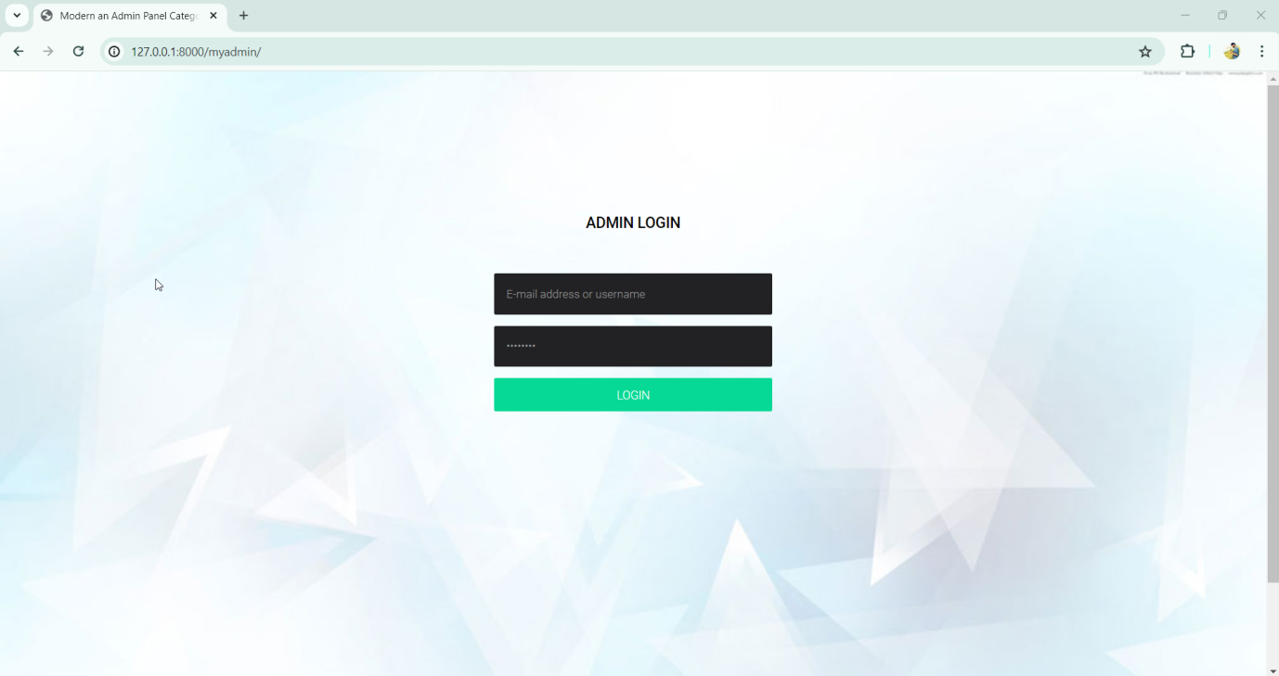

**Description :-**

This screen-shot is about admin login. Admin can login from here and manage all the things from here(only use for admin).

**Admin Login Page:-**

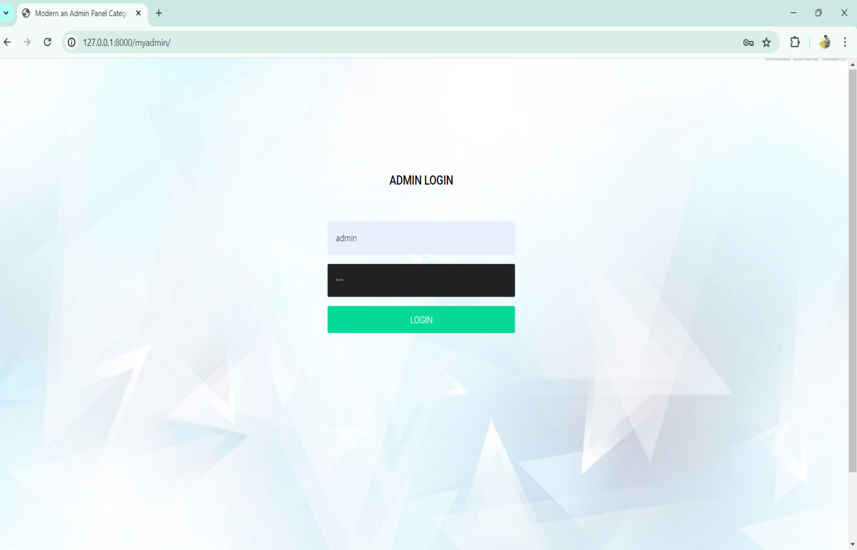

**Description :-**

This screen-shot is about admin login. Admin can login from here. This is a separate layout for admin work.

**Dashboard:-**

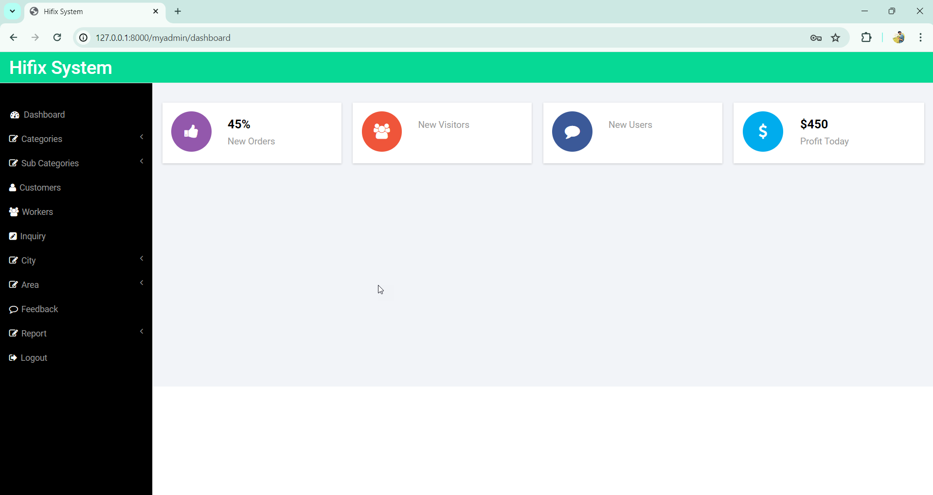

**Description:-**

This screenshot is about admin dashboard page. In this page admin can access all the functions and manage customers and workers.

**Add Category :-**

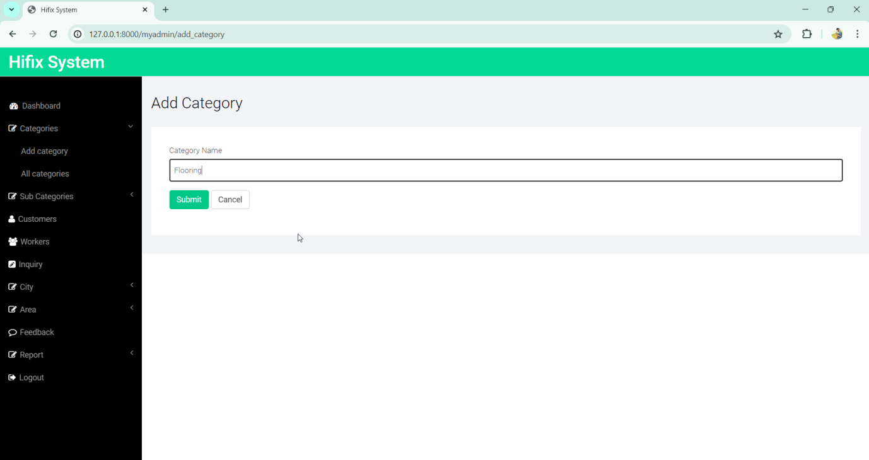

**Description:-**

This screenshot is about admin add category page. Admin can add category through this page.

**View all category:-**

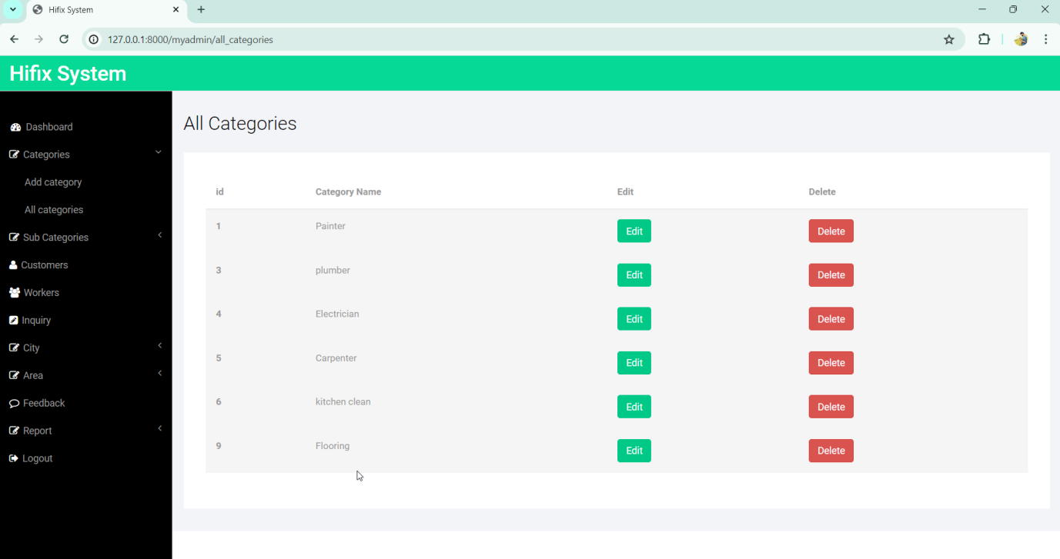

**Description:-**

This page is about admin view all category page . In this page admin can view all the categories as well as admin can edit and delete category.

**Edit Category:-**

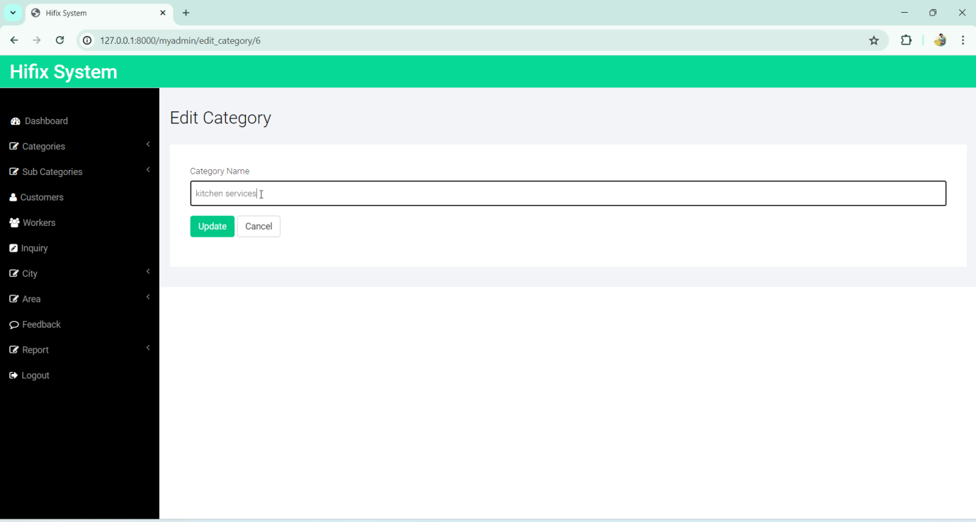

**Description:-**

This is admin edit category page. In this admin can edit the category .

**View Updated Category:-**

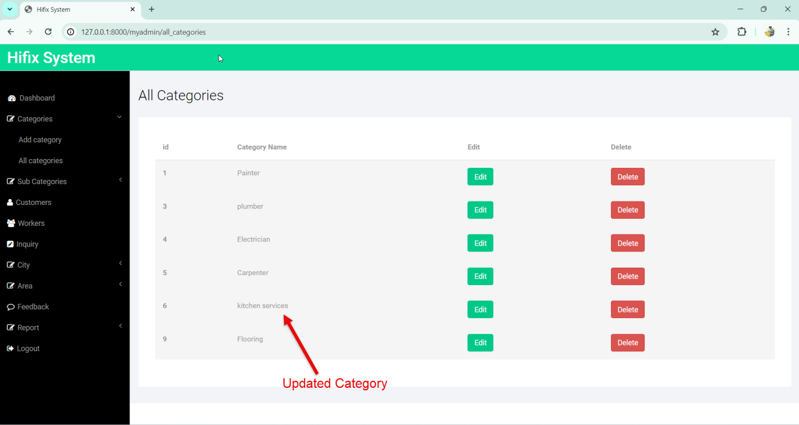

**Add Sub_category:-**

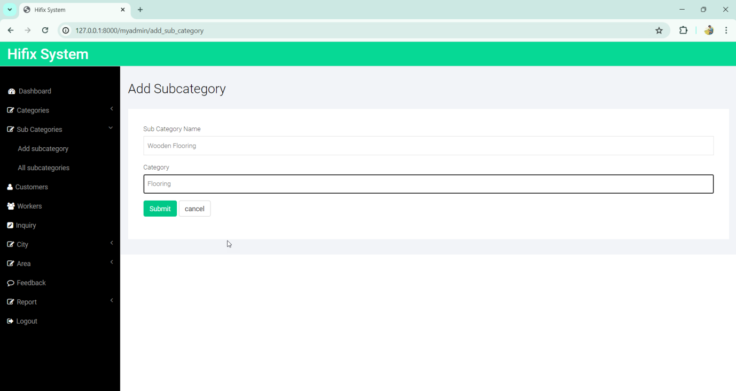

**View All Sub_category:-**

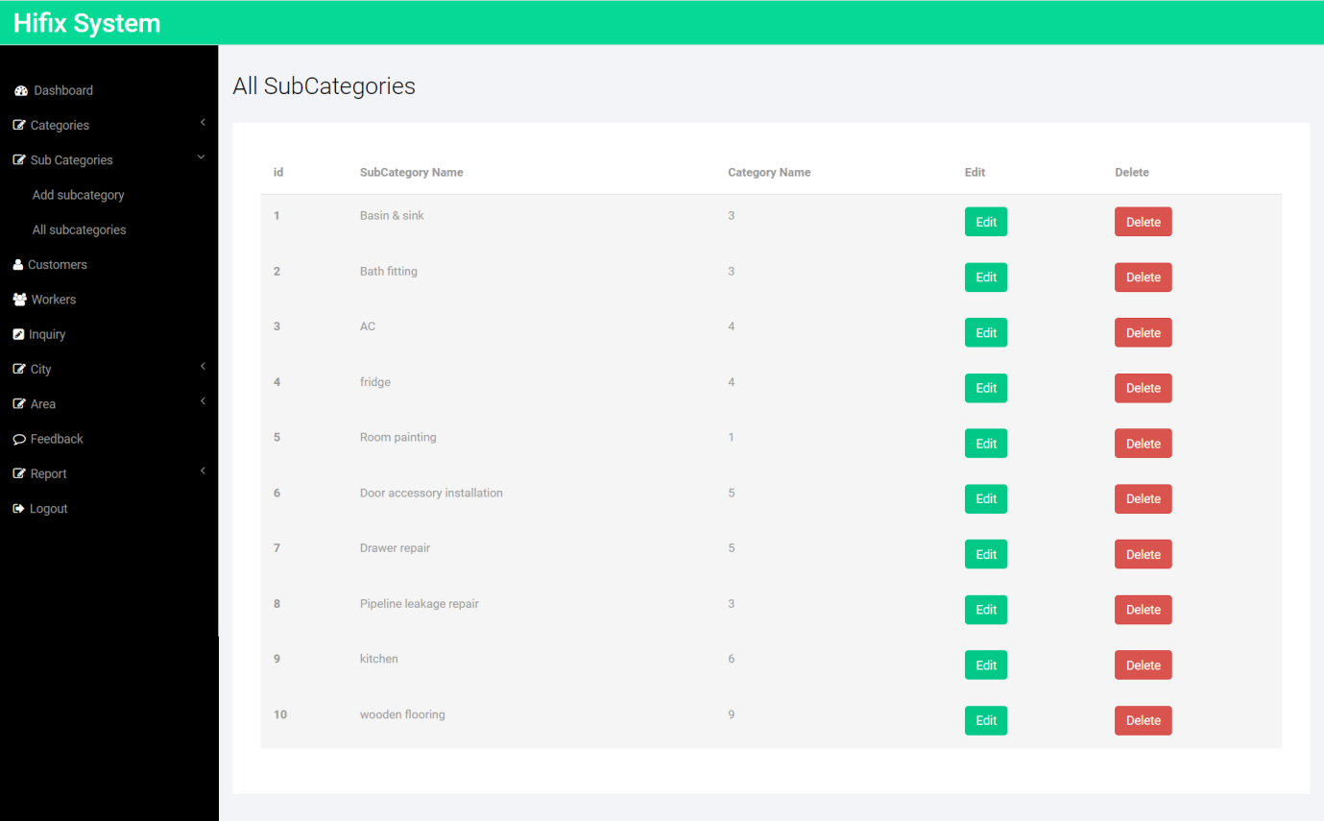

**Manage All Customers:-**

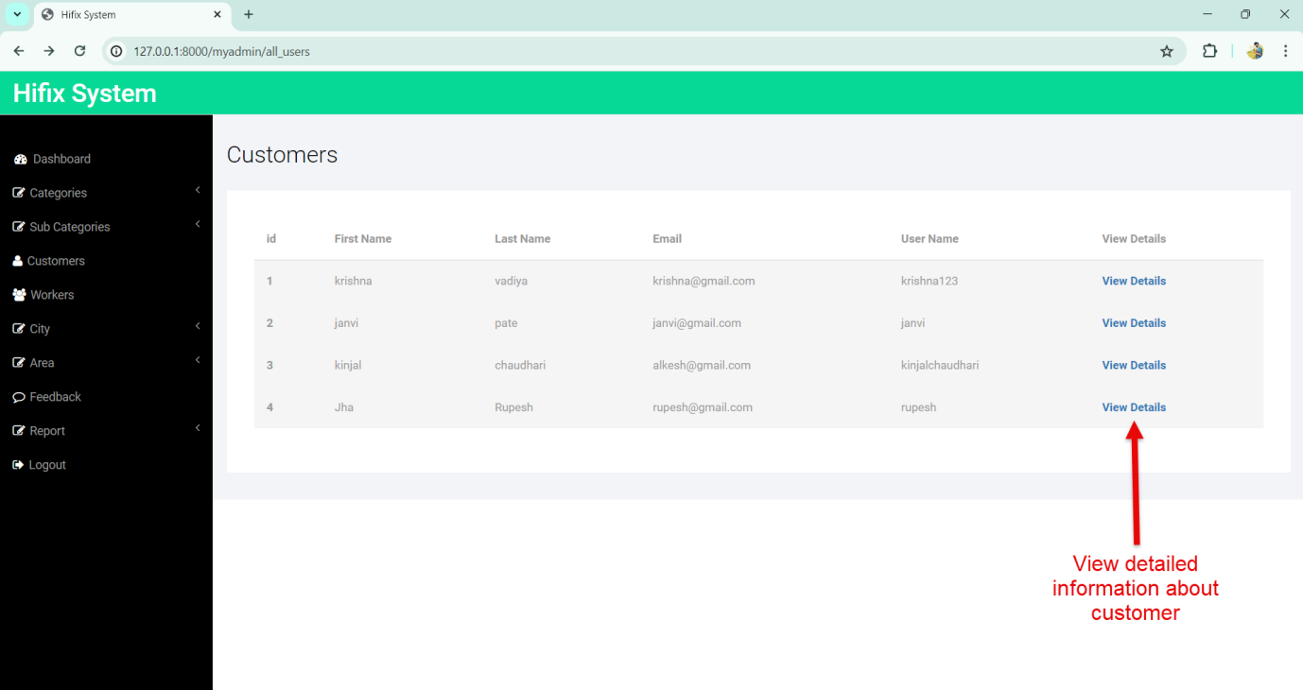

**Description:-**

This is admin view customer page . Admin can see the detailed information about customer.

**View Details:-**

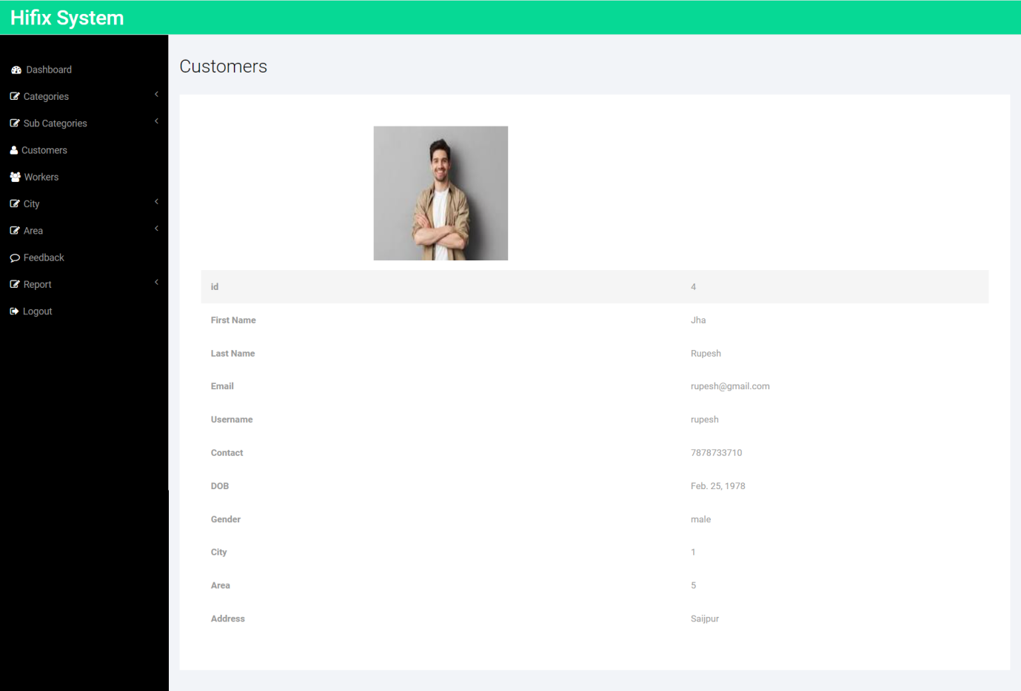

**Manage Workers:-**

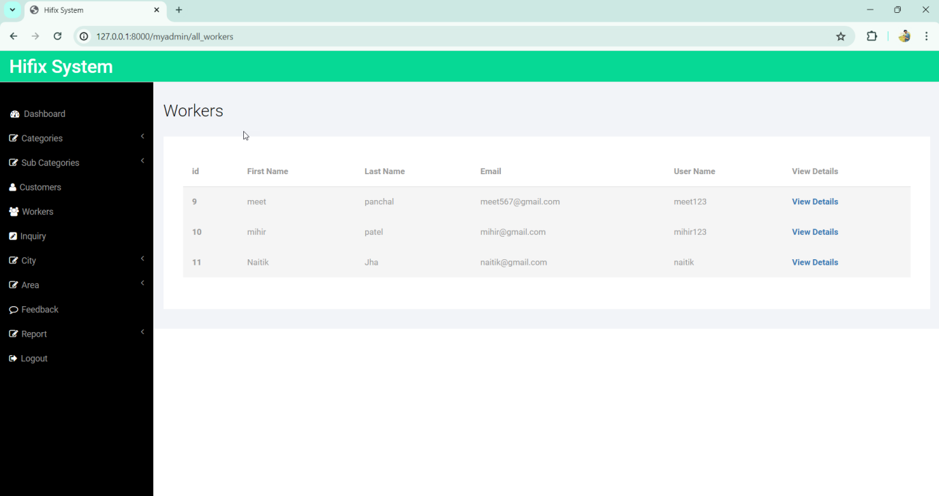

**Add City:-**

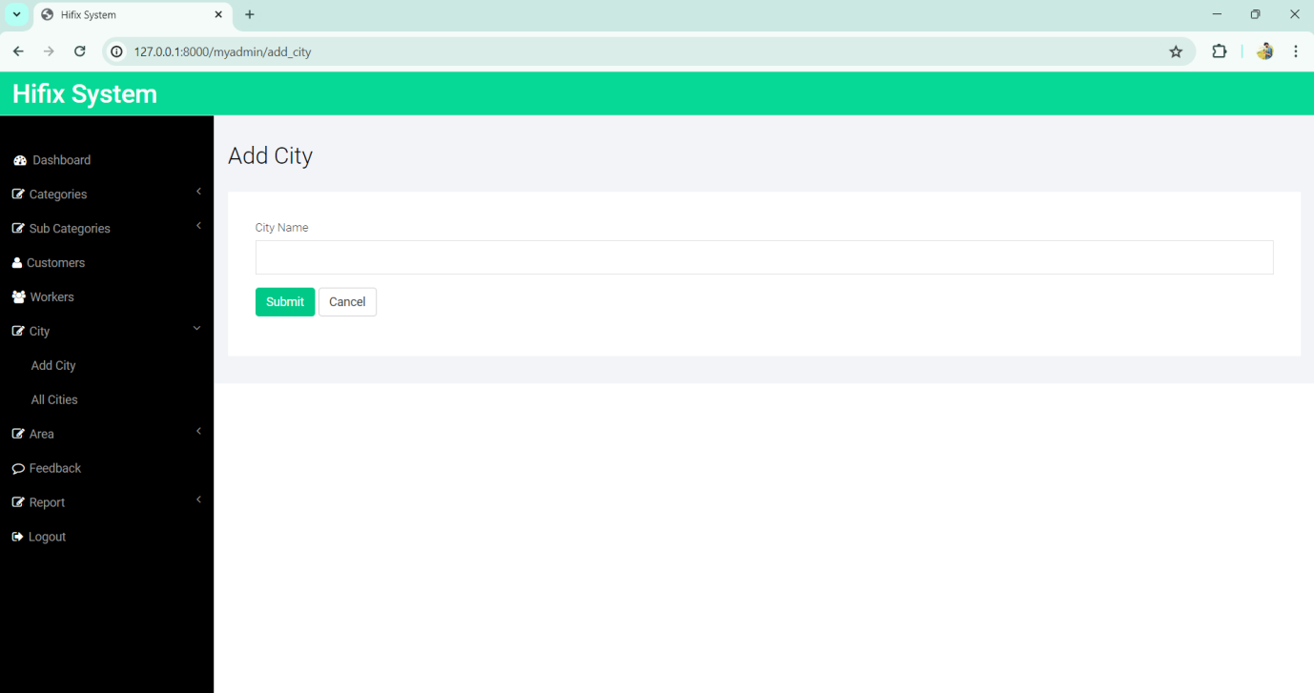

**Add City Details:-**

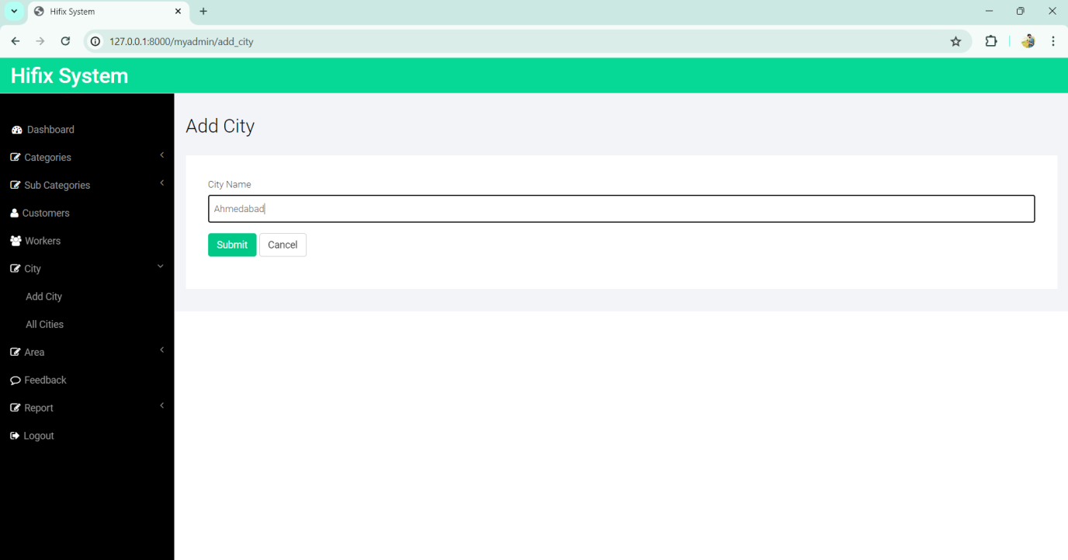

**View City:-**

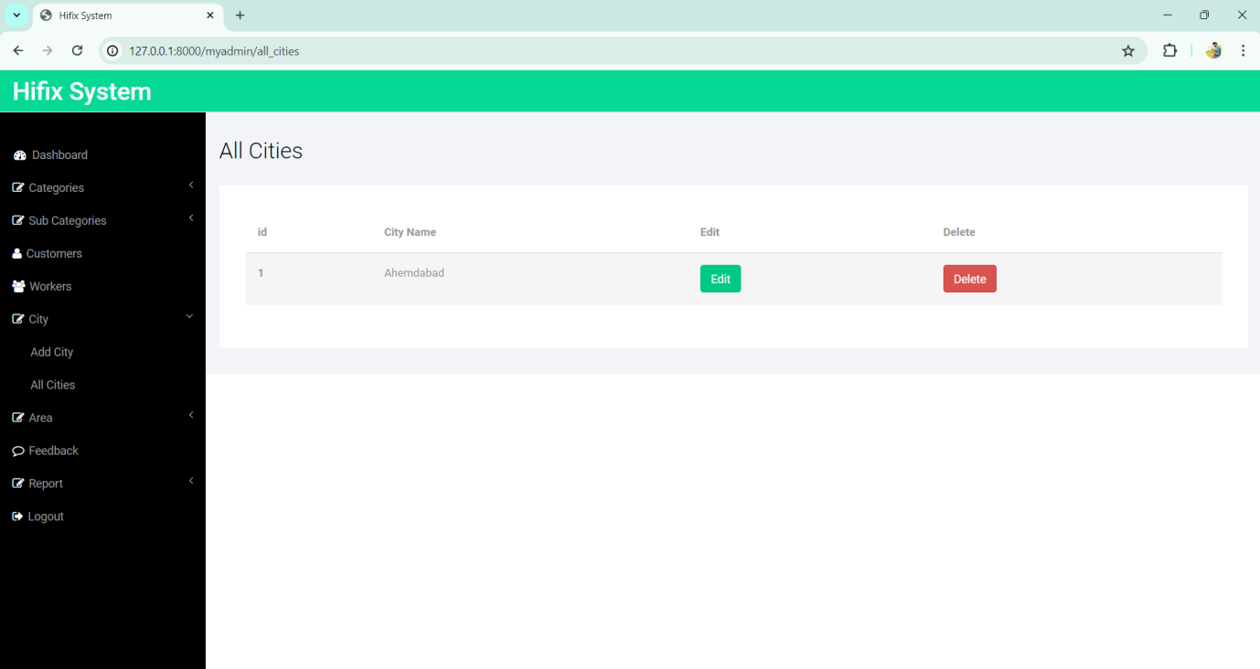

**Add Area:-**

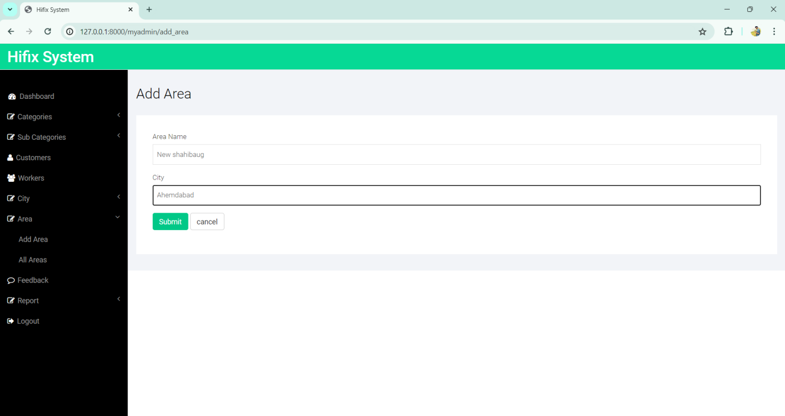

**View All Area:-**

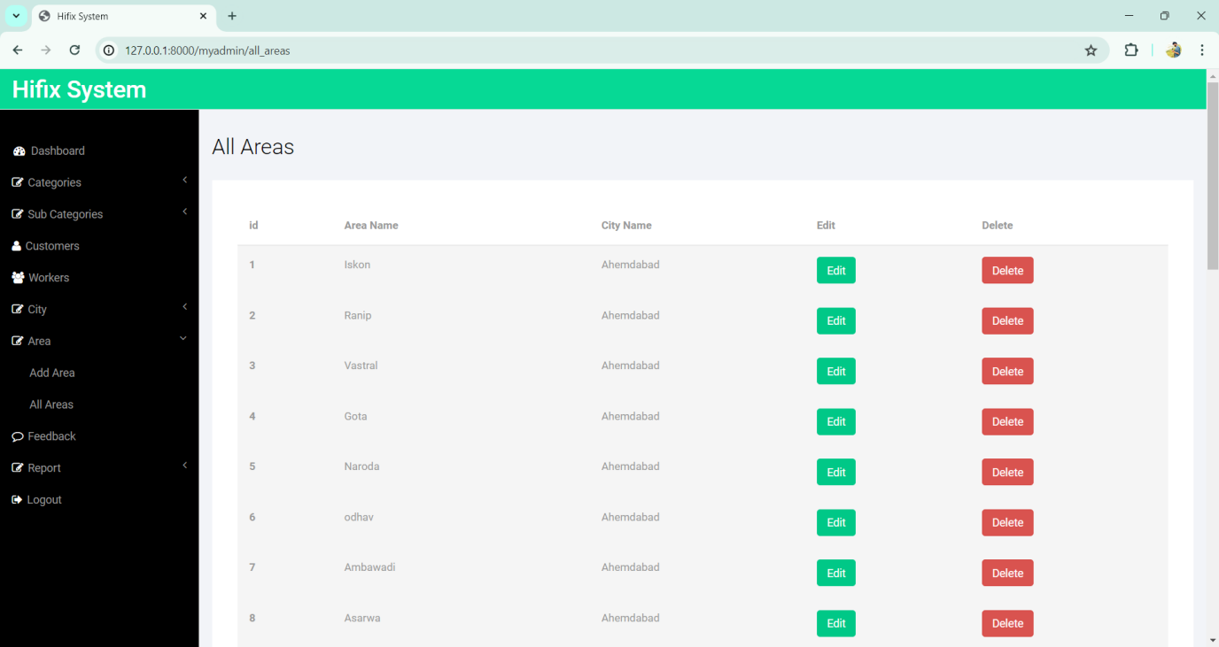

**View All Feedback:-**

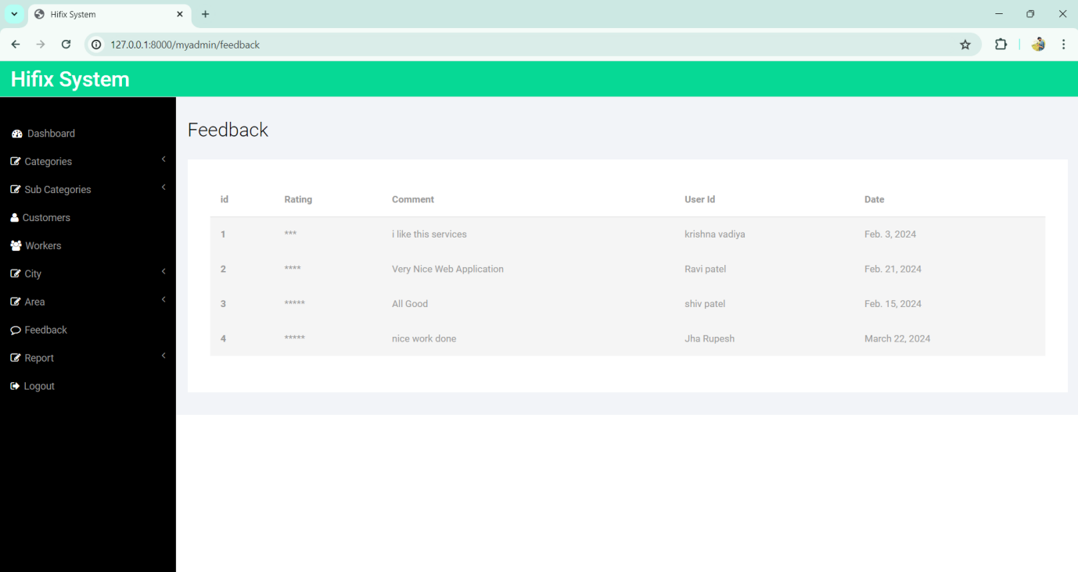

USER LAYOUTS

**Home Page:-**

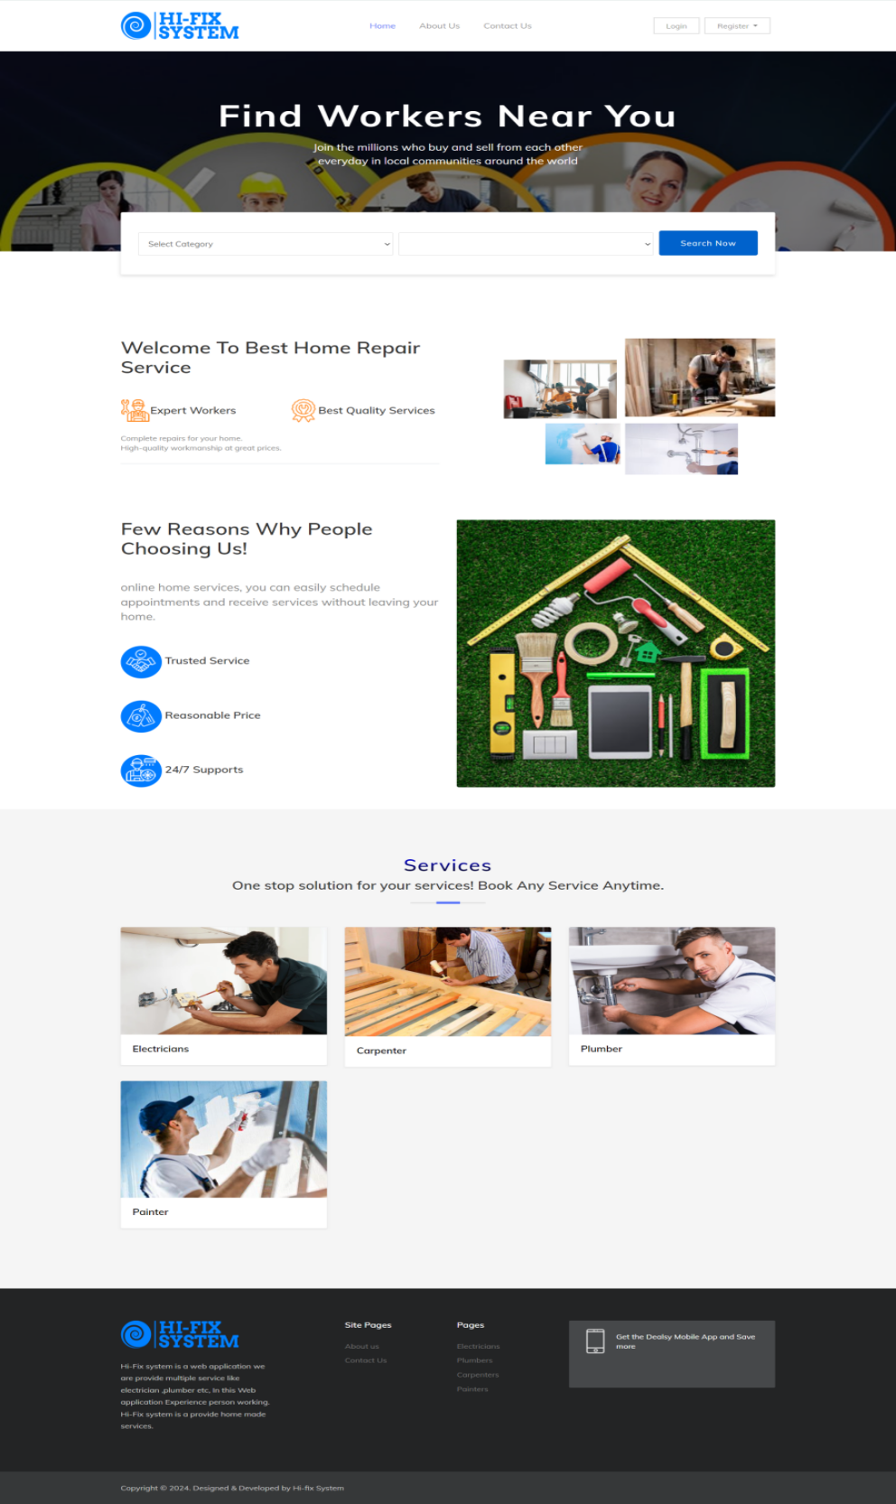

**Register As User:-**

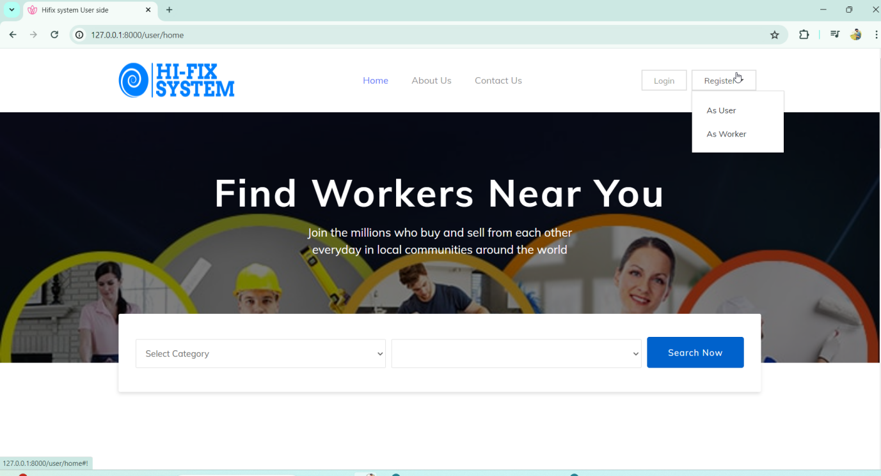

**User Register Page:-**

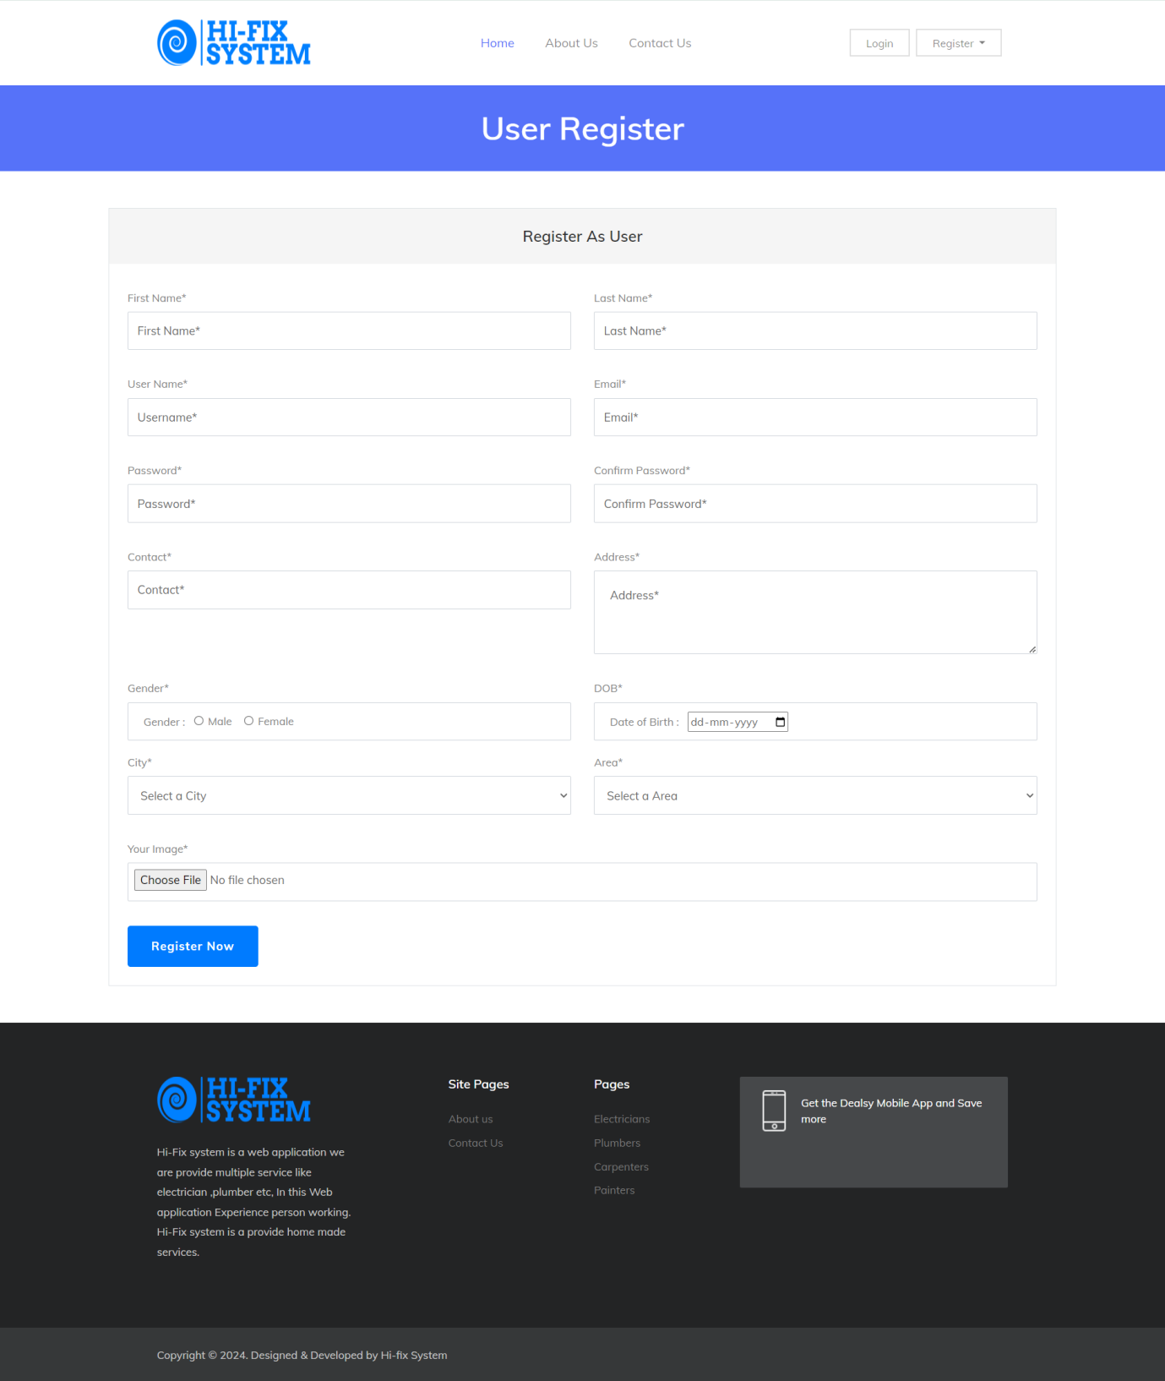

**User Login Page:-**

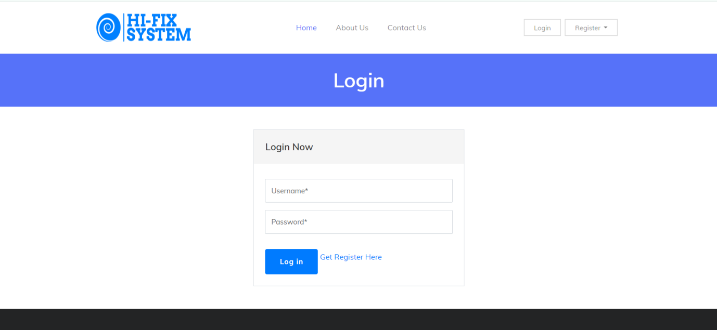

**Invalid User:-**

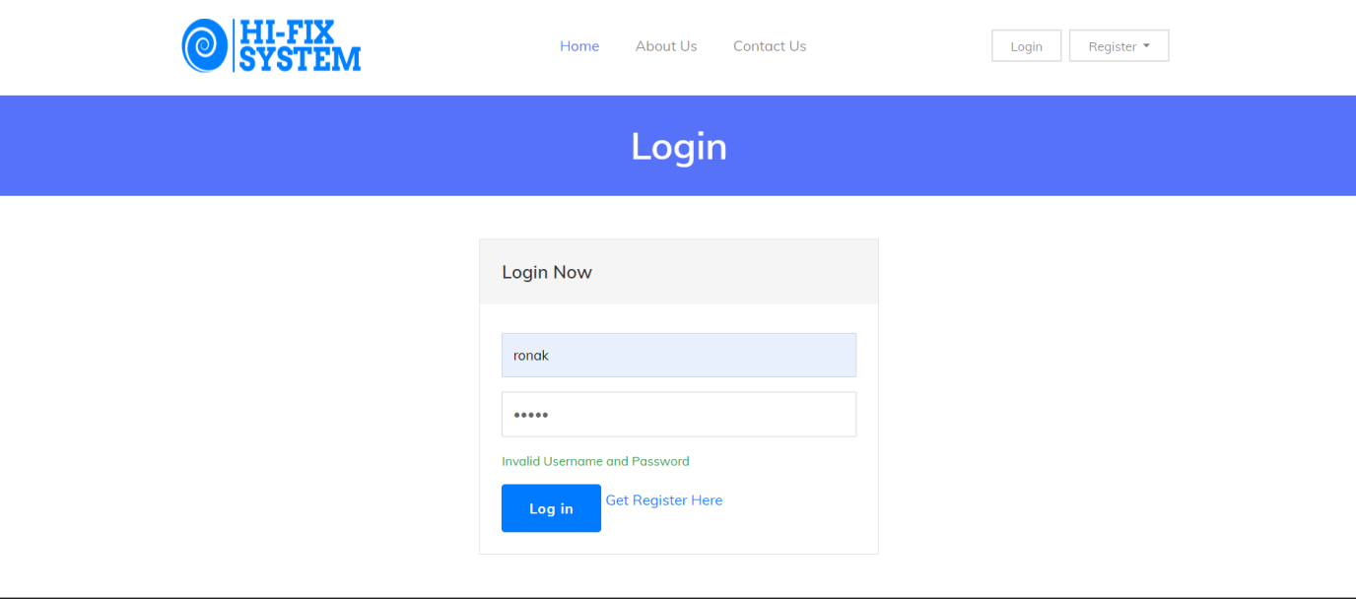

**Settings:-**

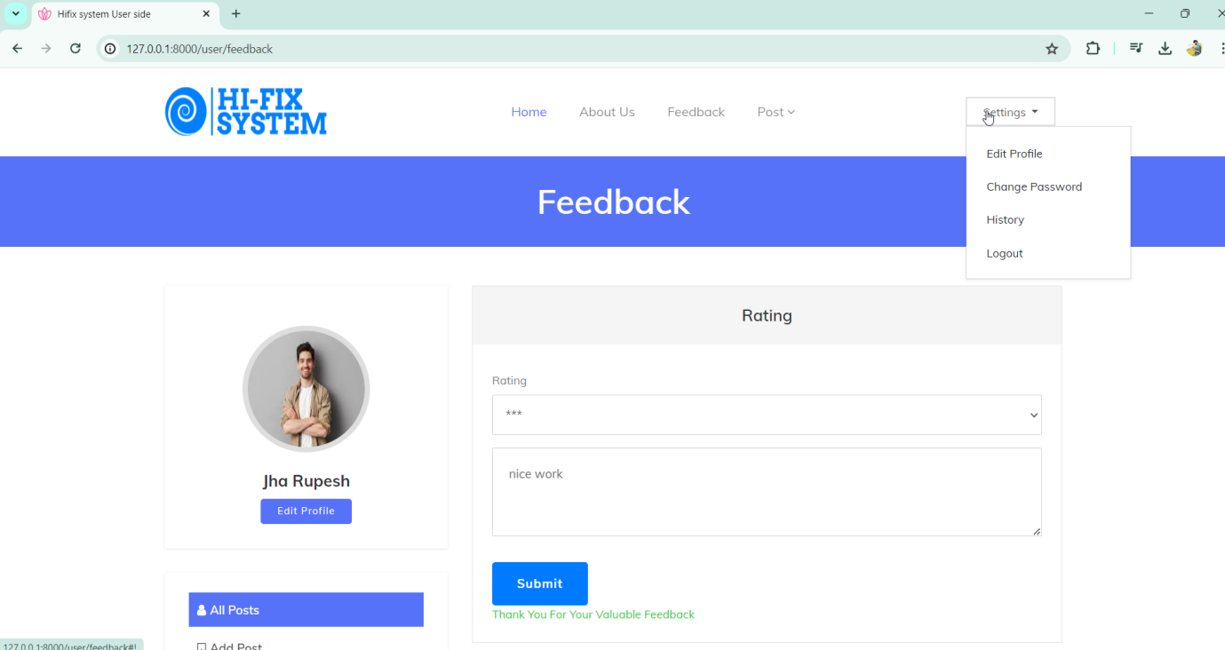

**Change Password Page:-**

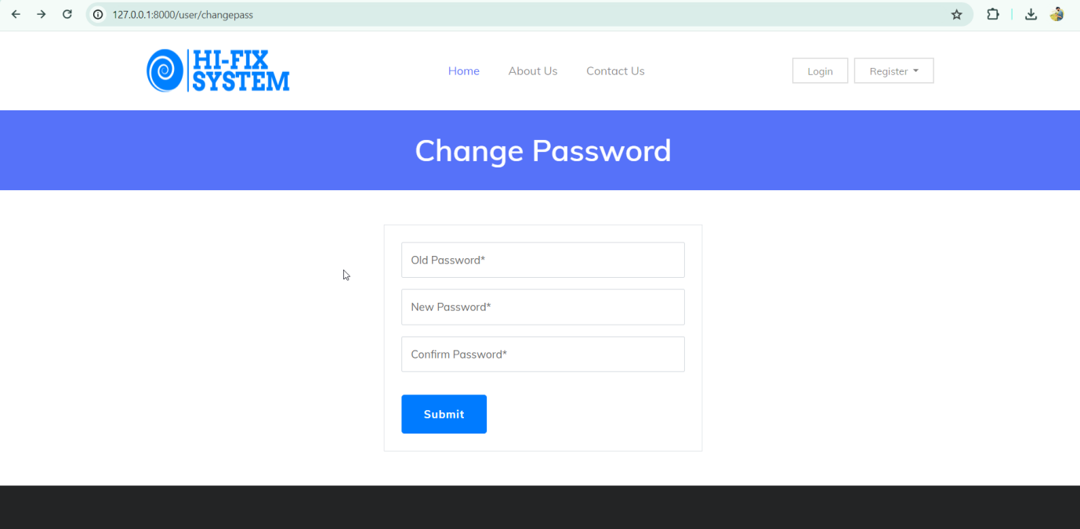

**Add or View All Post:-**

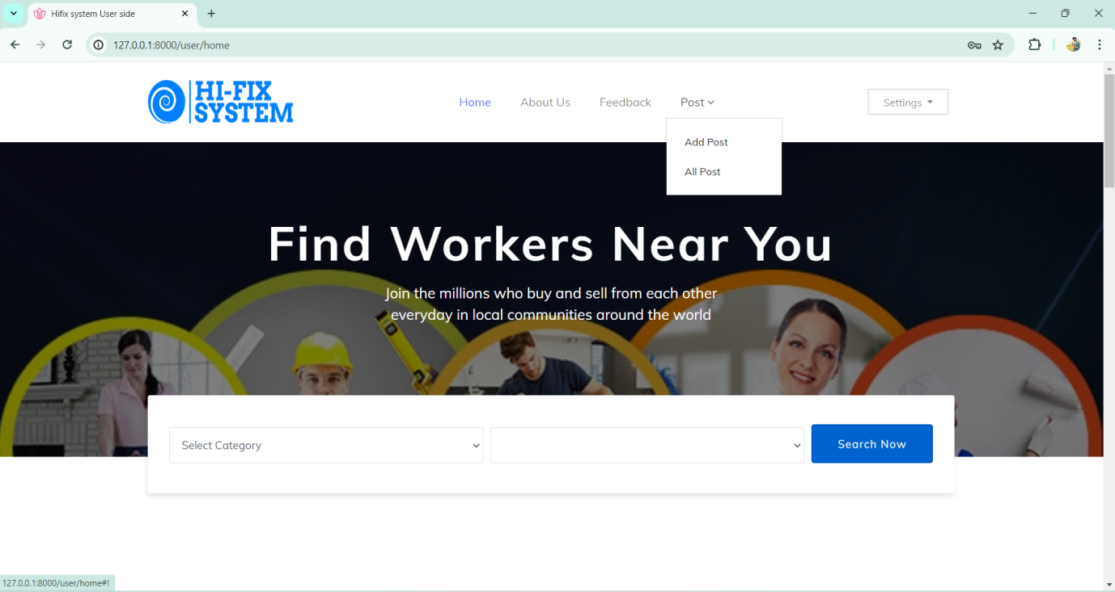

**User Post Page:-**

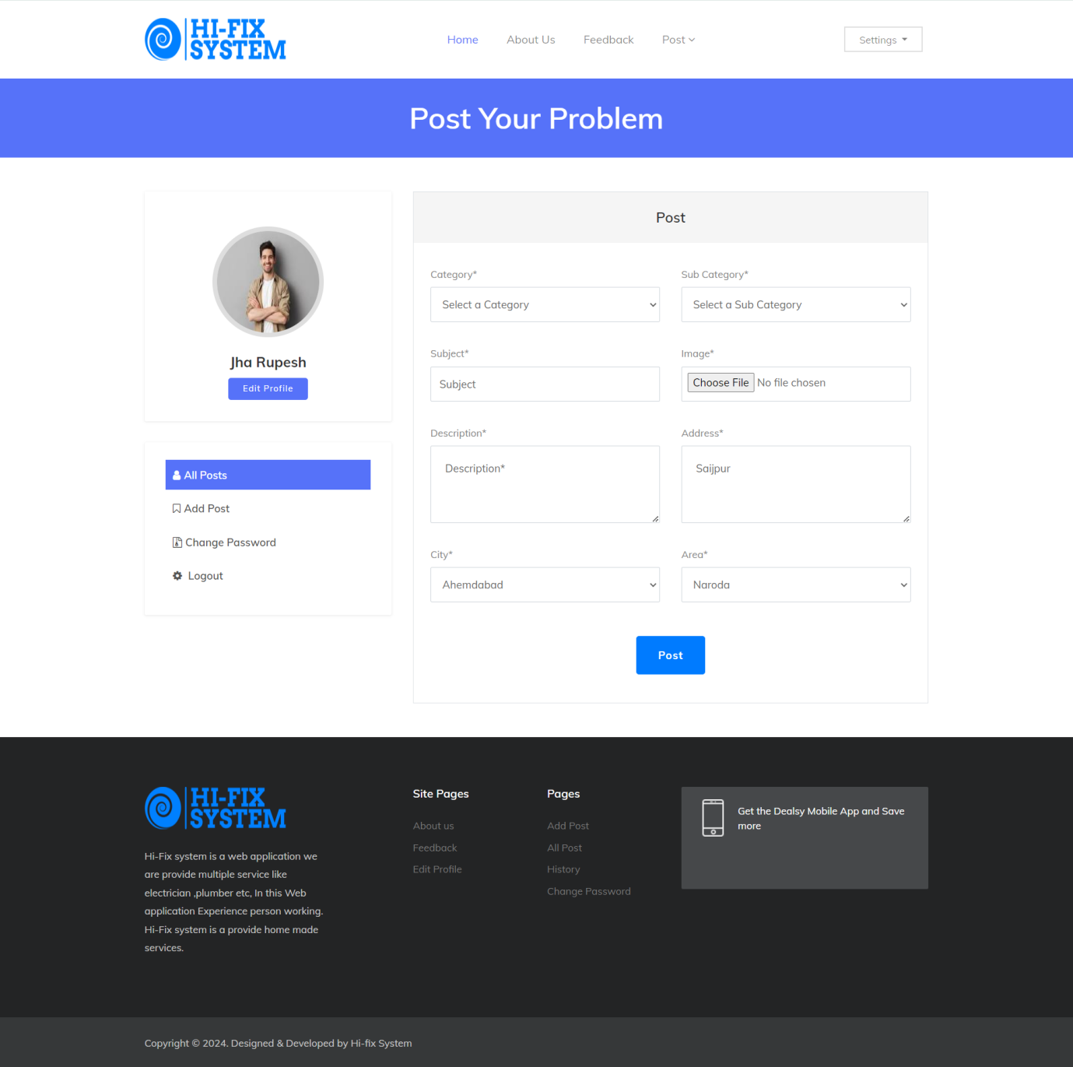

**Post Successfully :-**

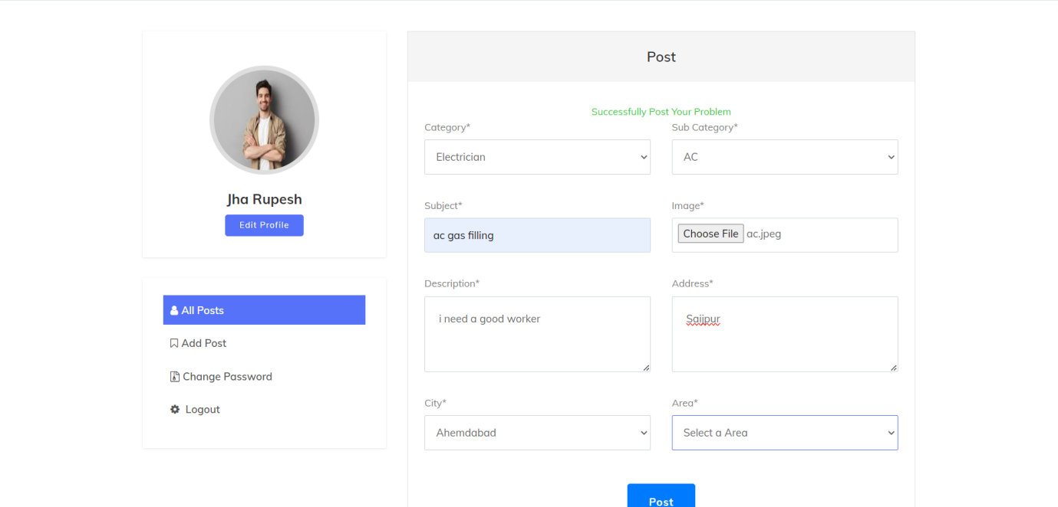

**User All Post Page:-**

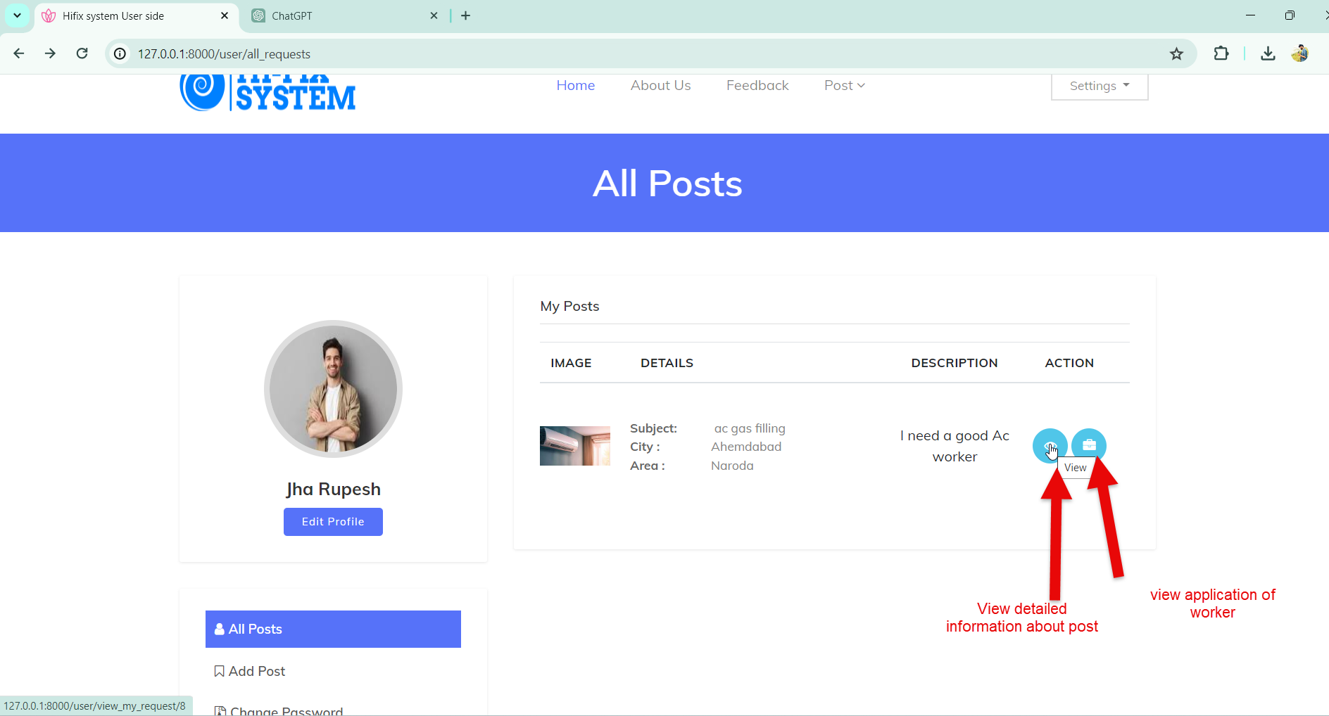

**View Detailed Post Page:-**

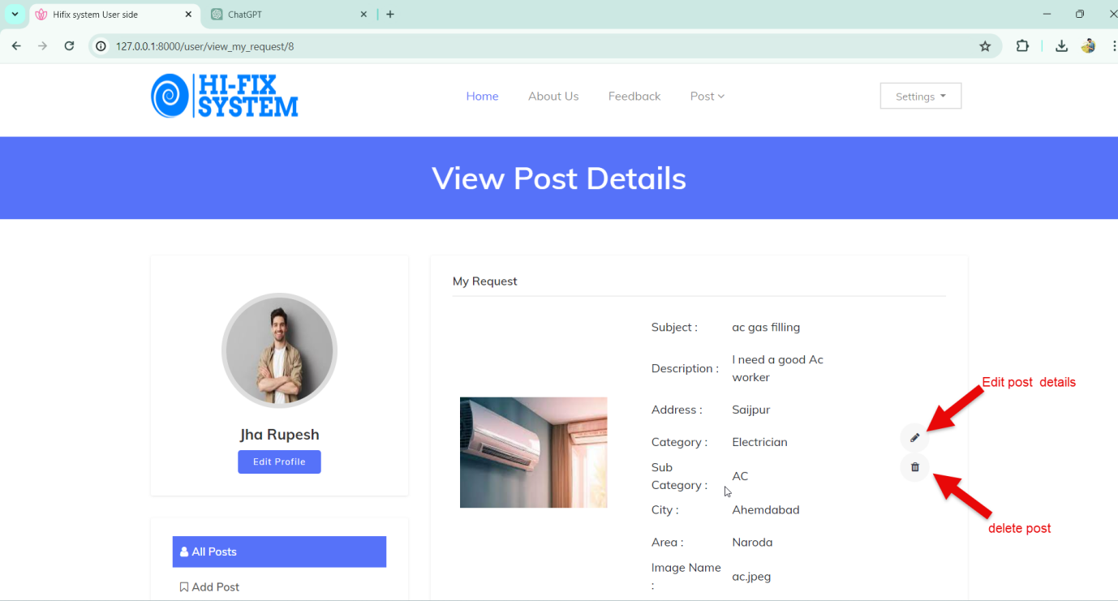

**Edit Post Page:-**

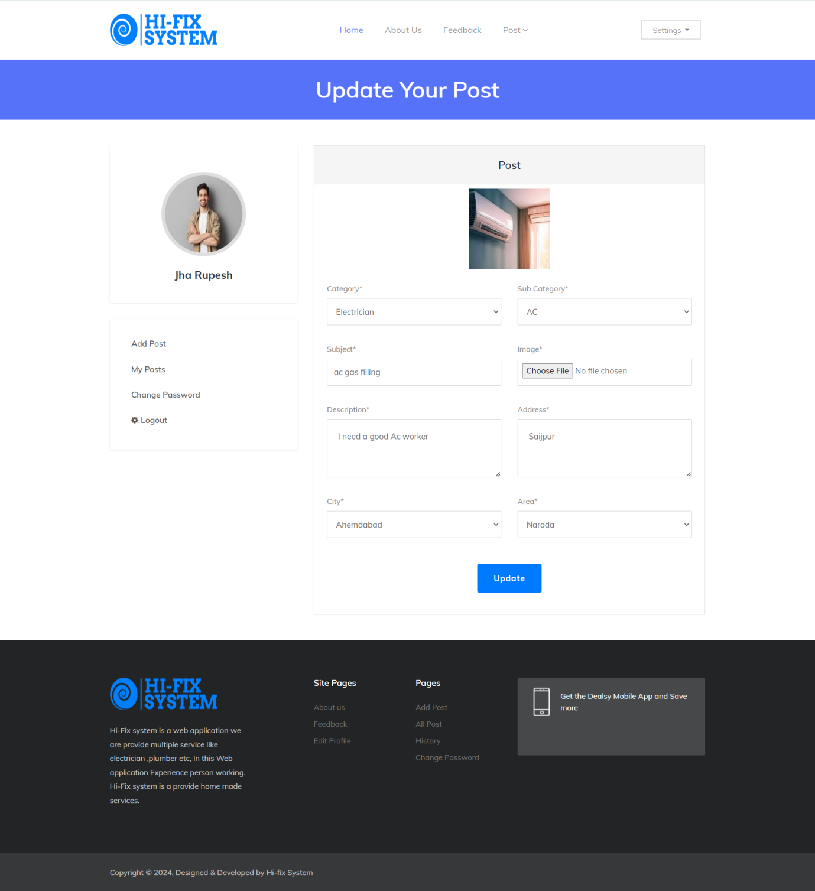

**View Worker Application:-**



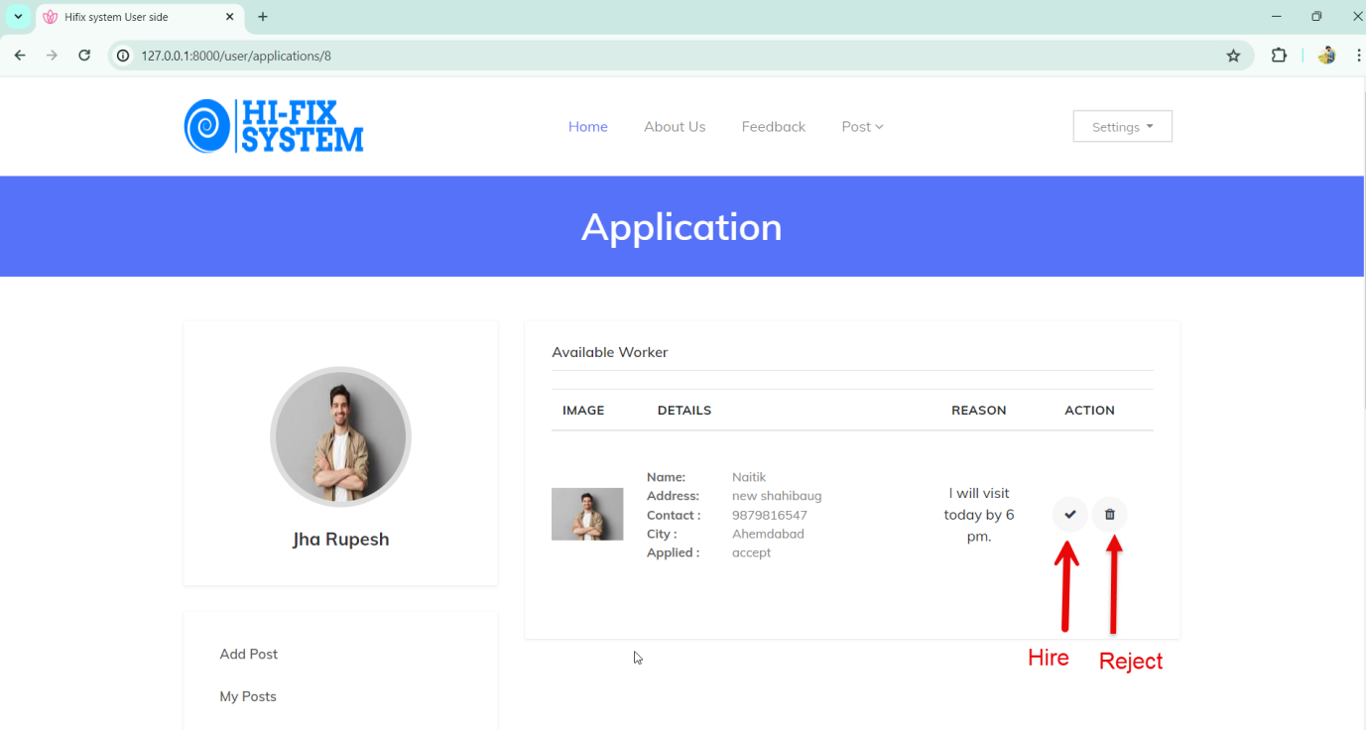

**Hire Worker Page:-**

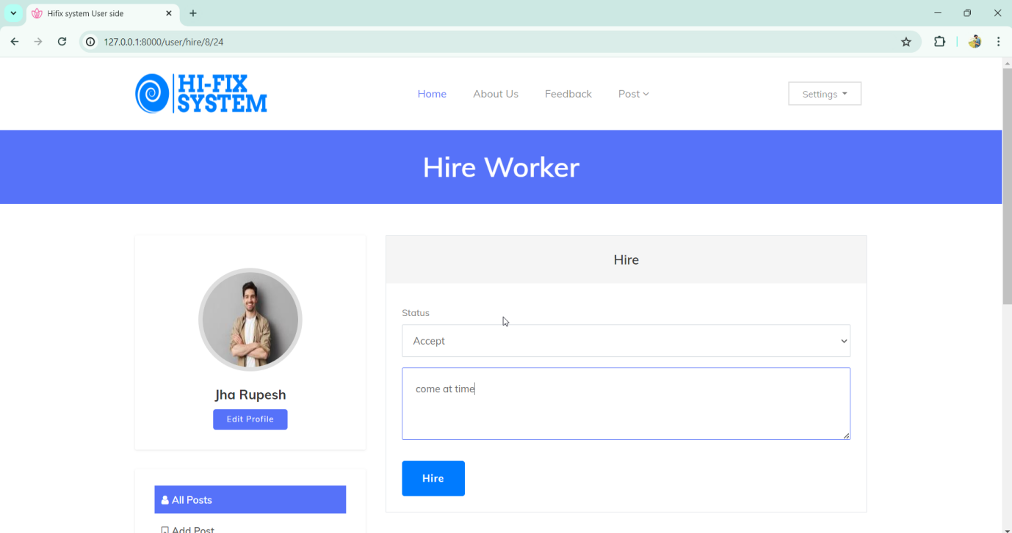

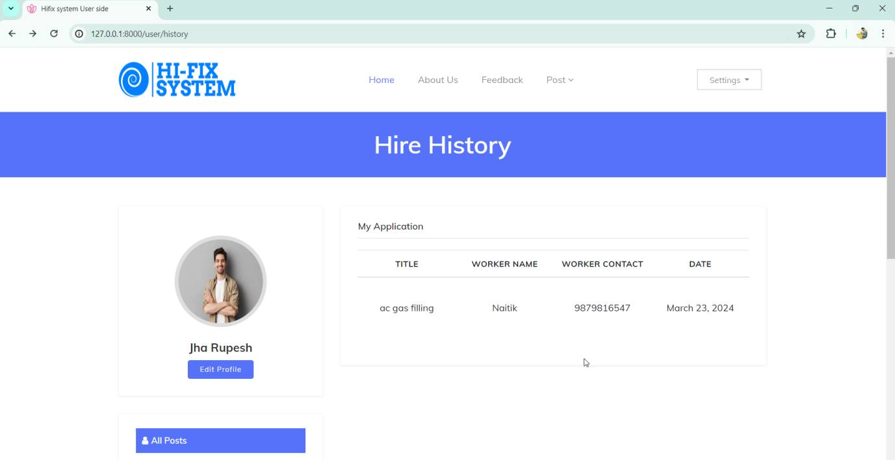

Edit Profile page:-

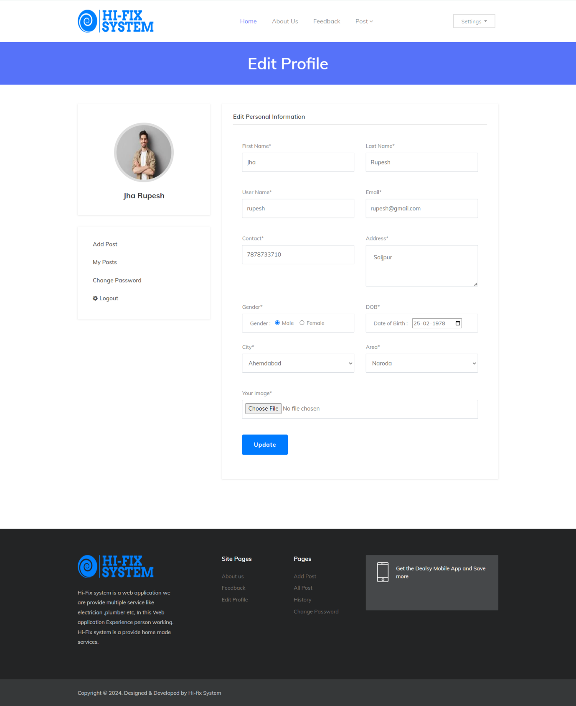

**Feedback Page:-**

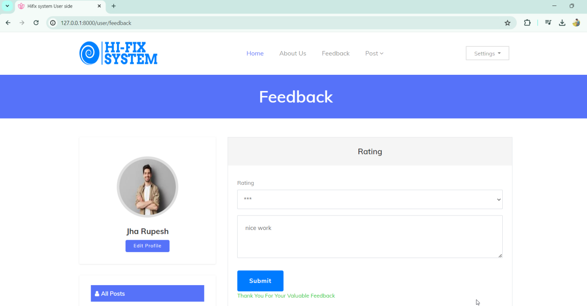

**AboutUs Page:-**

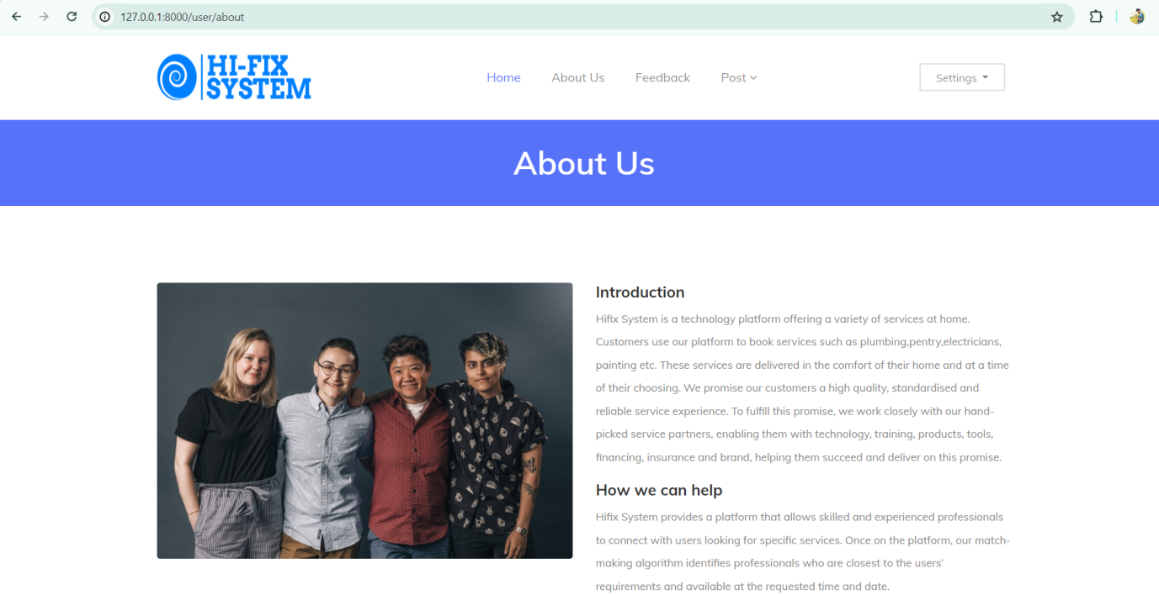

WORKER LAYOUT

**Worker Home Page:-**

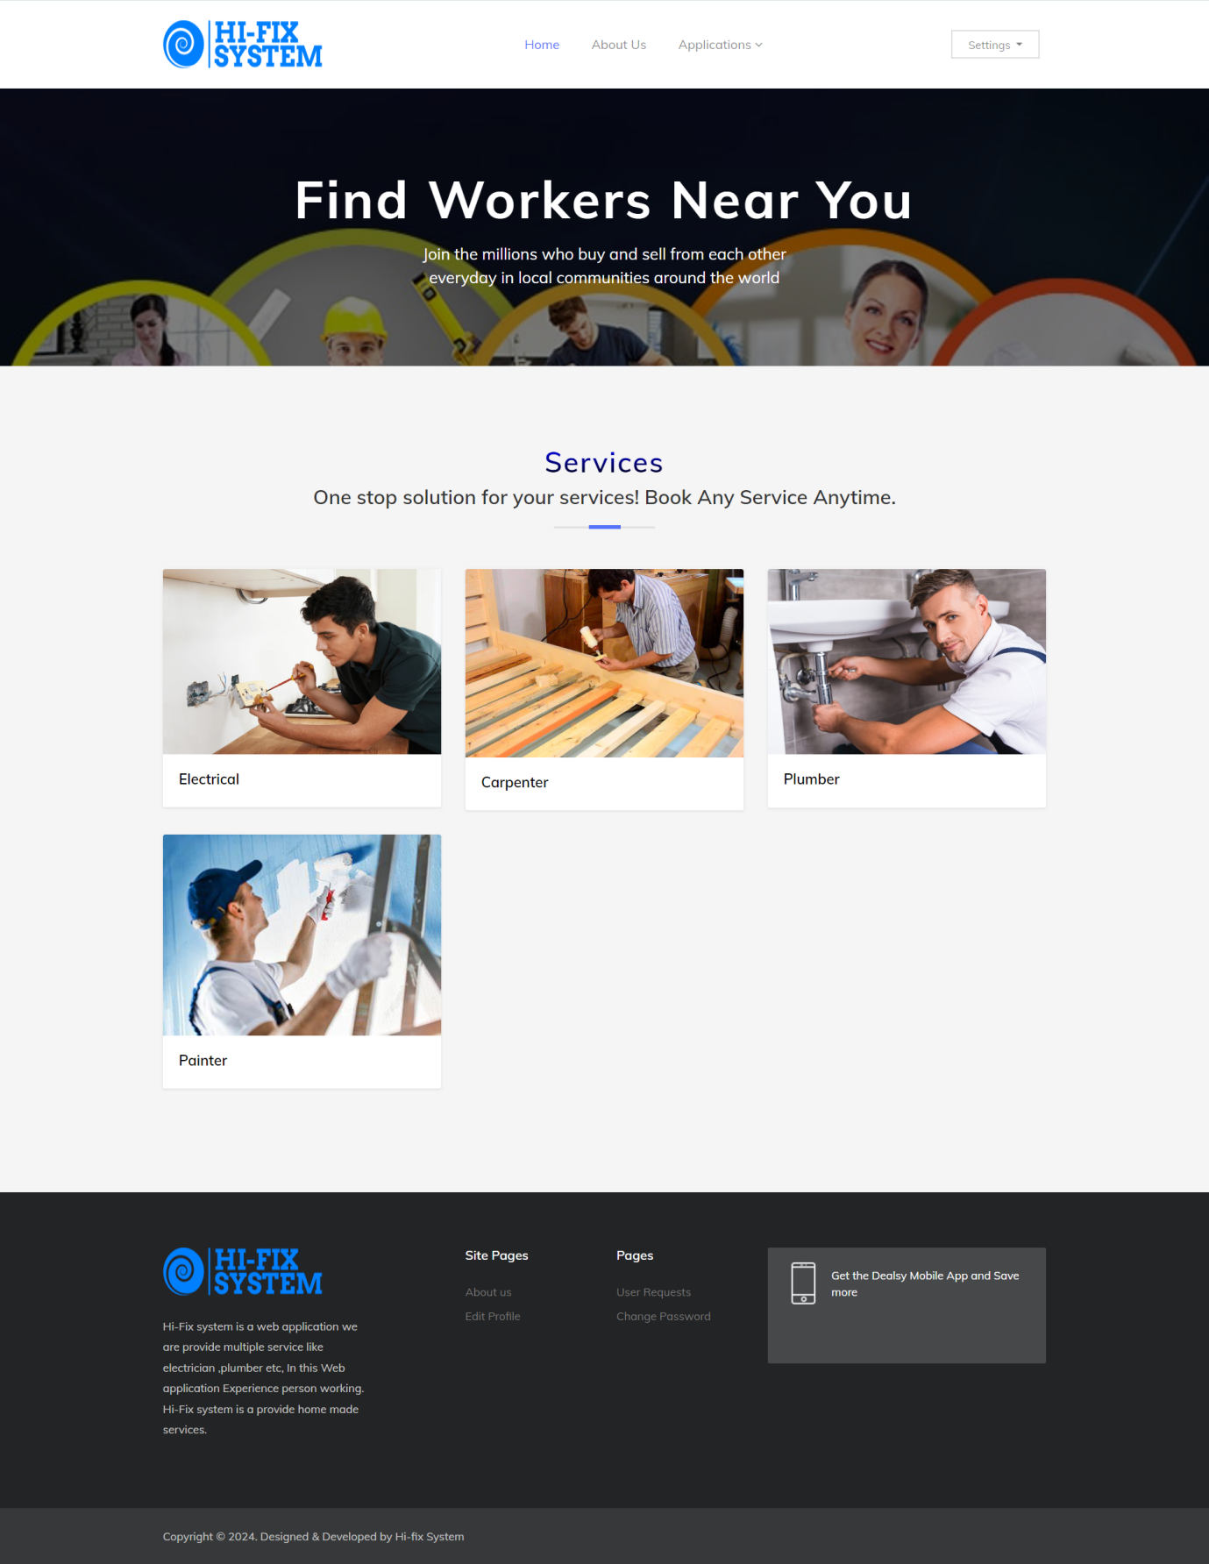

**Worker Register Page:-**

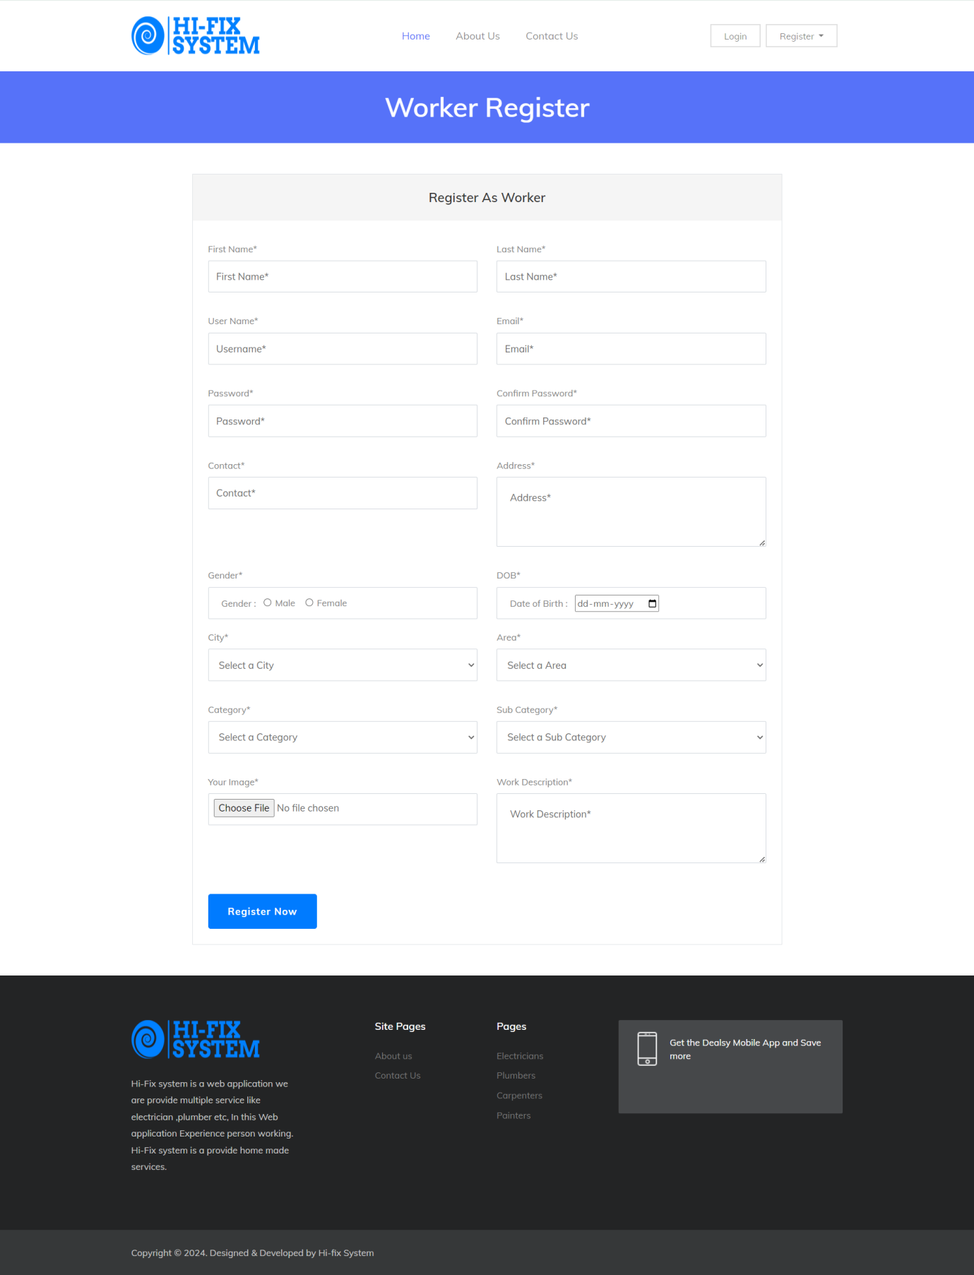

**Contact Us page:-**

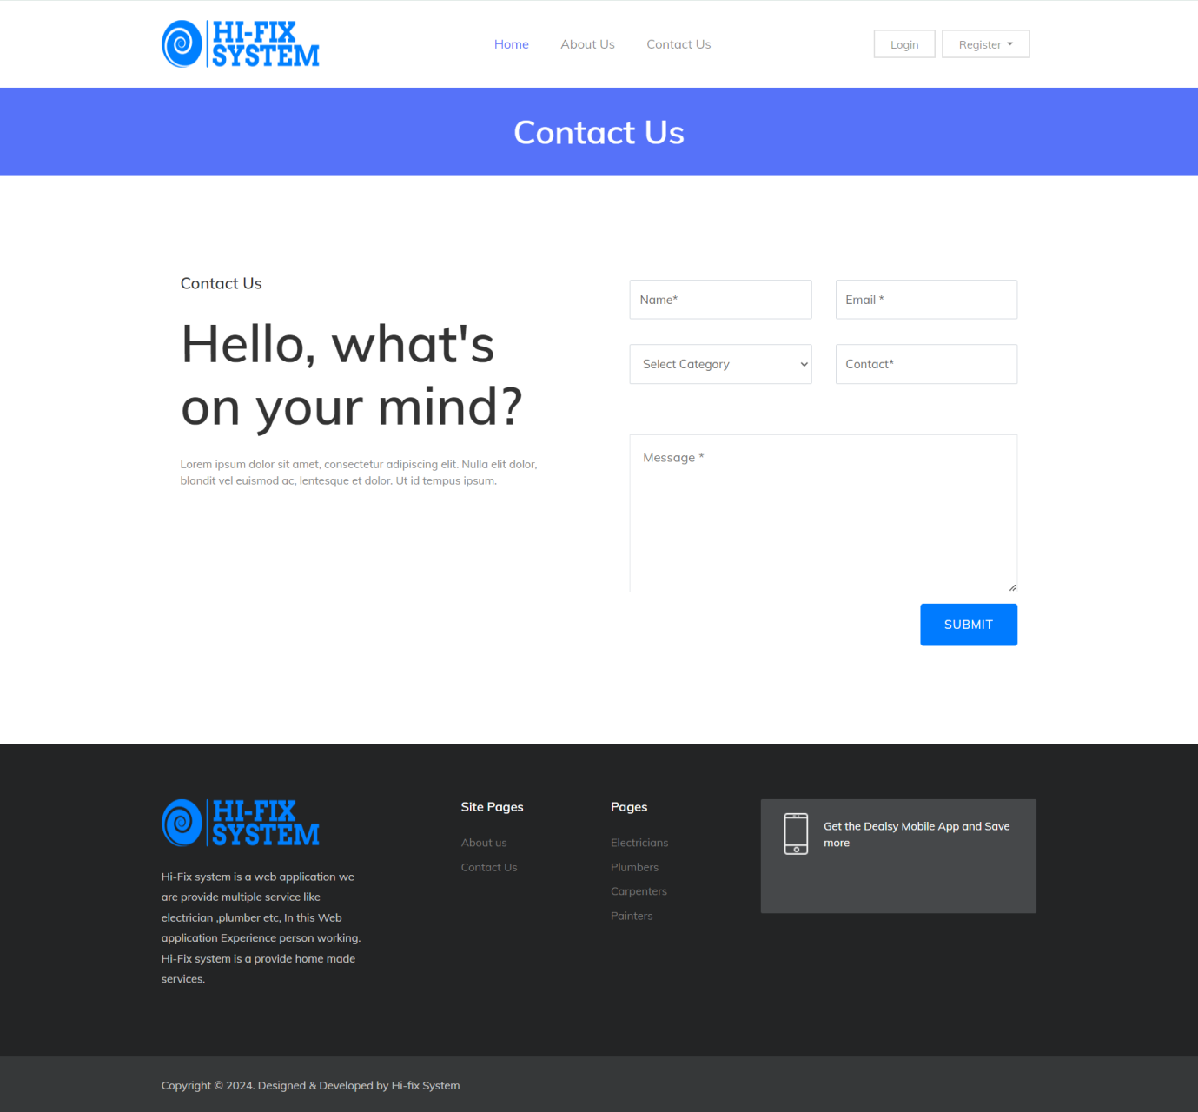

**View User Request:-**

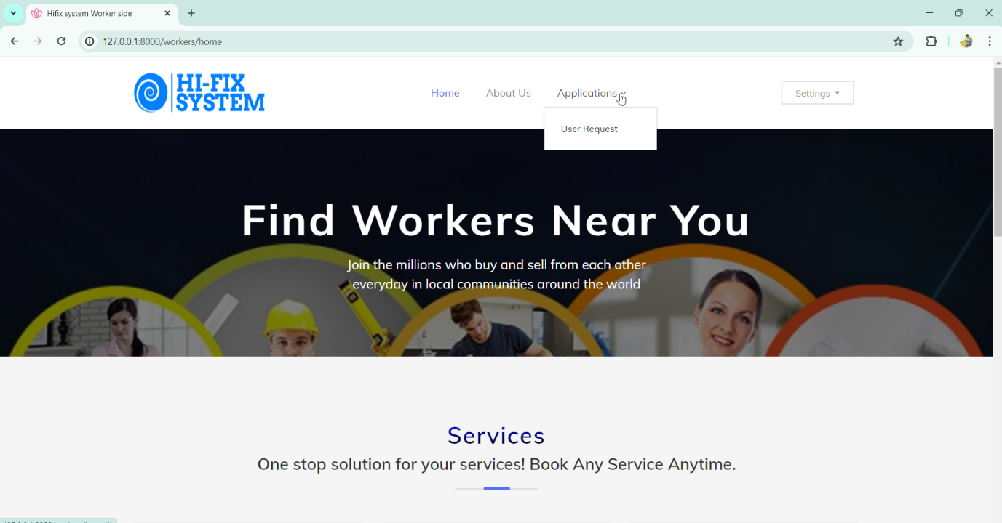

**User Request Page:-**

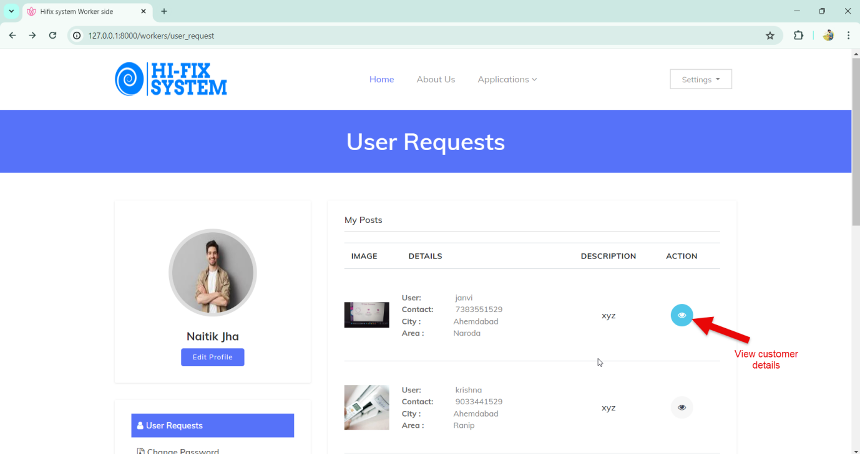

**Detailed User Post:-**

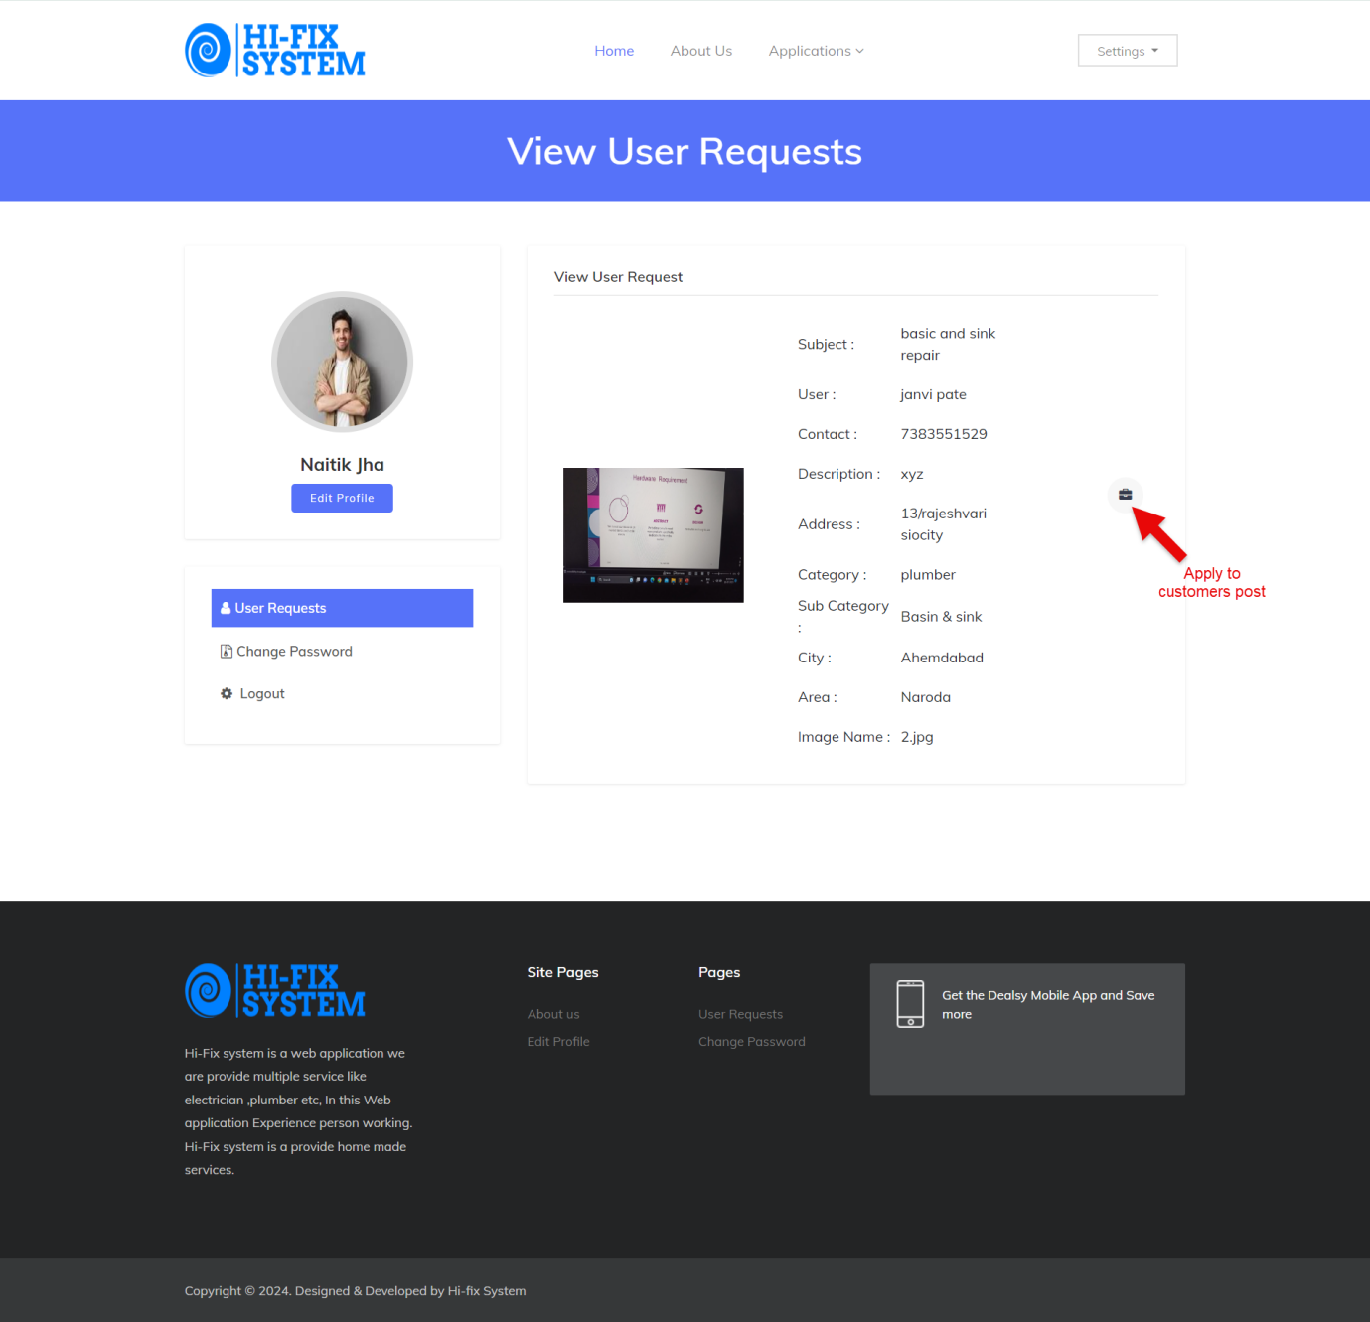

**Apply User Post Page:-**

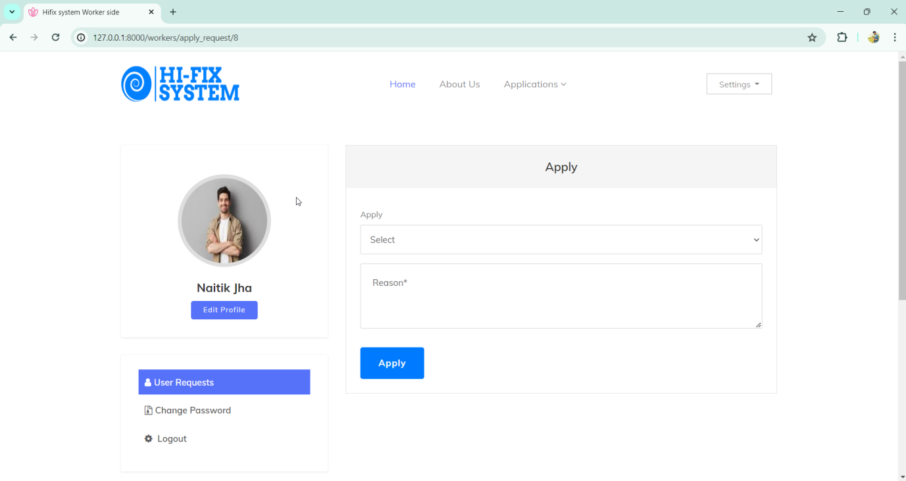

**Accept_Reject Page:-**

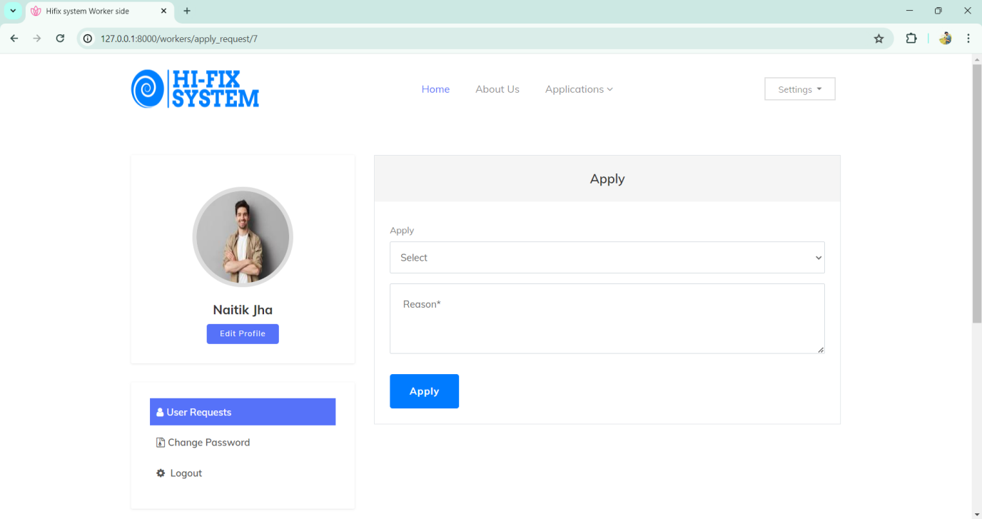

REPORT LAYOUTS

**Worker Report:-**

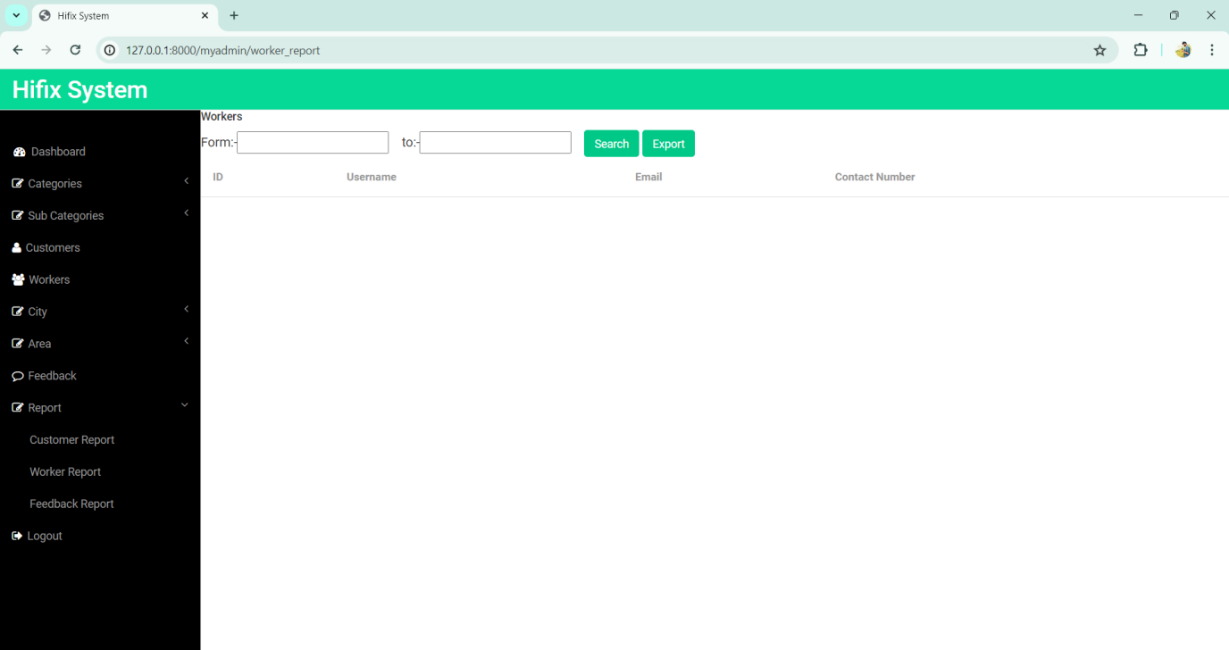

**Add Date :-**

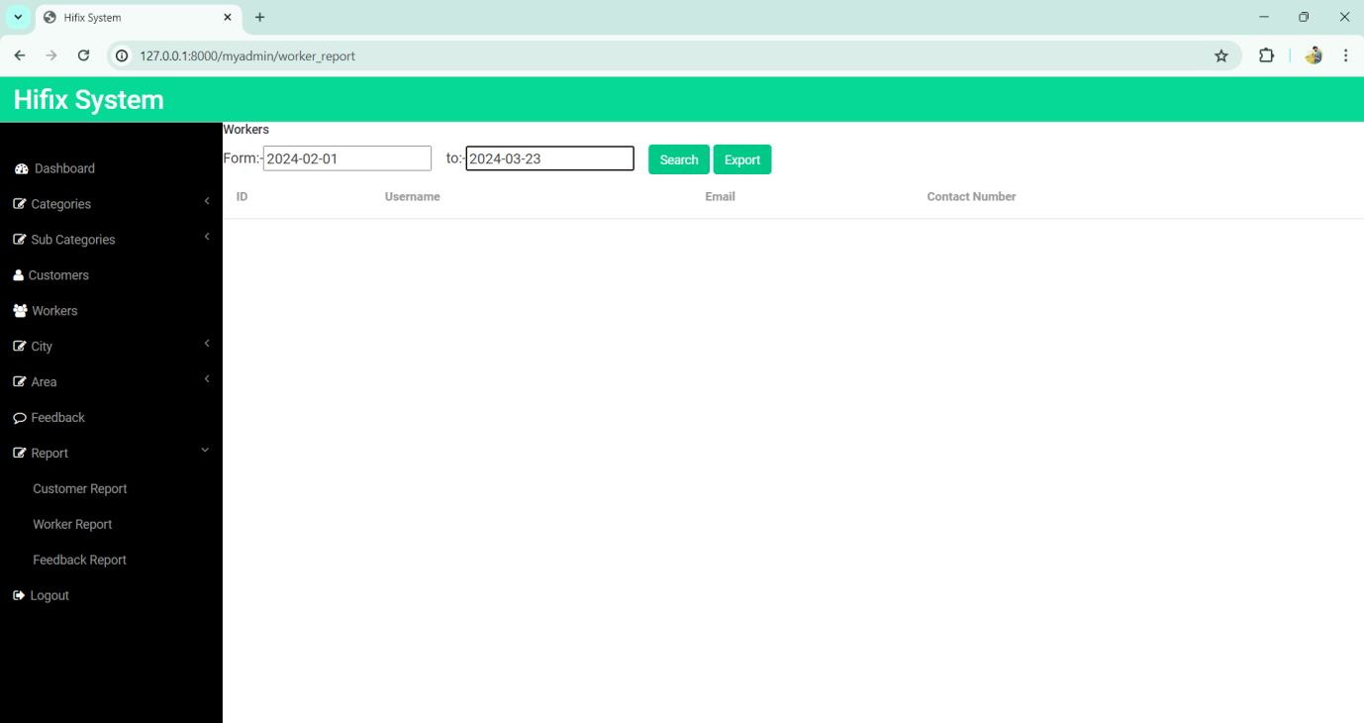

**Worker_Report:-**

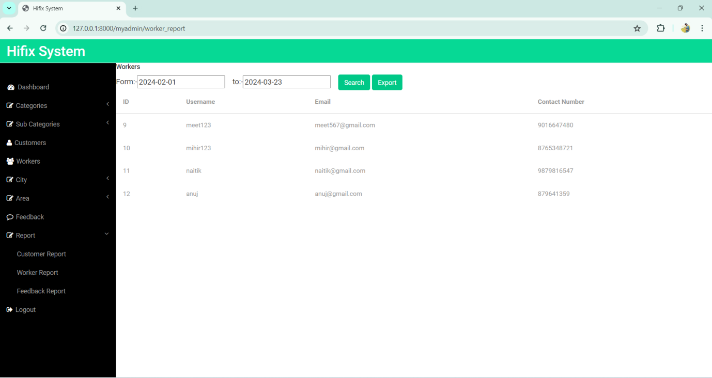

**Customer Report:-**

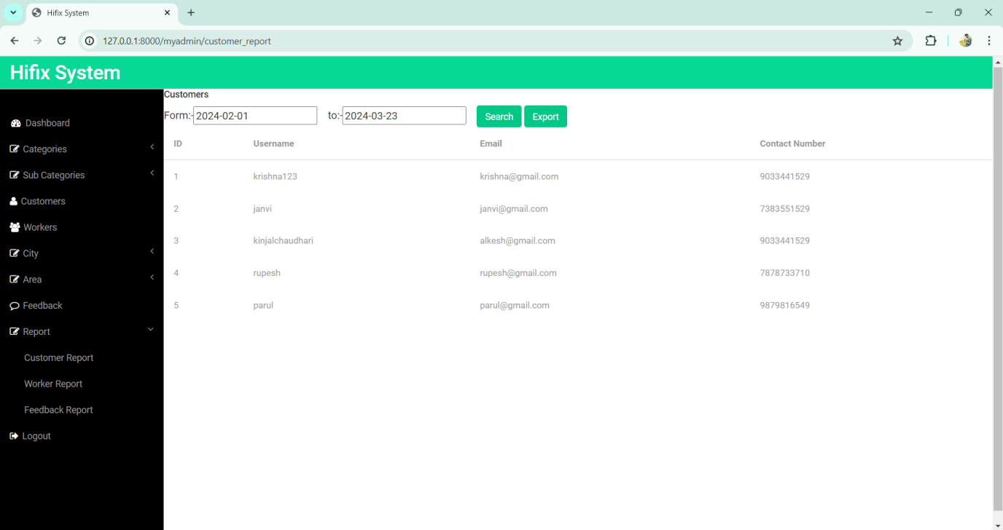

**Feedback Report:-**

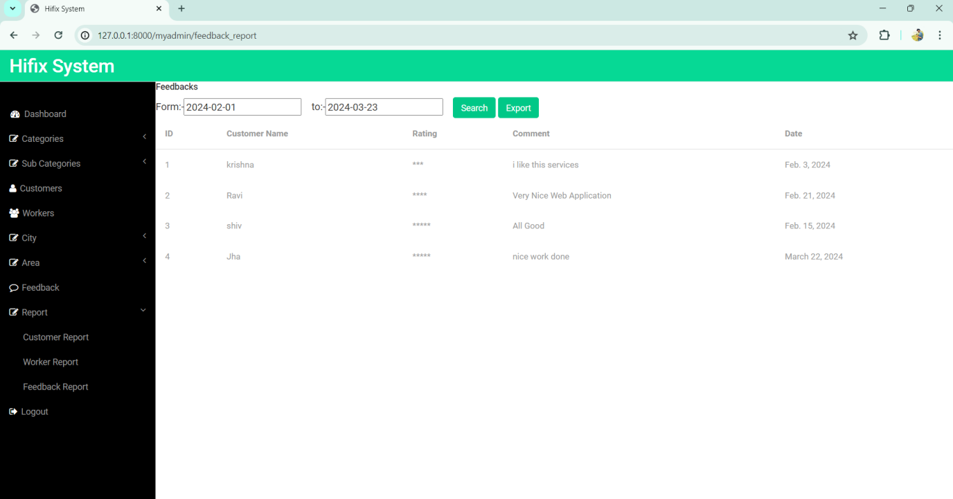

**Conclusion:-**

Hifix system is a web-application which removes the intermediate between a user and a worker. It is a system by which a user can upload the post of his requirement .Requirement can be related to any categories like Electrician, Plumber, Cleaner, Driver, Painter, Carpenter etc. as per the area and city .The worker from the same area can view and apply to the post. After Applying Worker, User can select any of them as per his convenience, reviews and budget.

Bibliography:

1. <https://www.geeksforgeeks.org/django-tutorial/>
2. <https://www.w3schools.com/django/>
3. <https://wiki.python.org/moin/Django>

LOG SHEET

THANK YOU